**CINS 370 Team Project Assignment 4**

**Phase 4: Advanced SQL**

**By Group 1**

The first 5 pages of this project is showing the screenshots of the datasets we used in this project from phase 1. There are 5 different tables that we loaded in sql, named as Population, Immigration, Income, Product and Poverty Table. We have used the same data to answer all the questions for this project.

**Population Table**

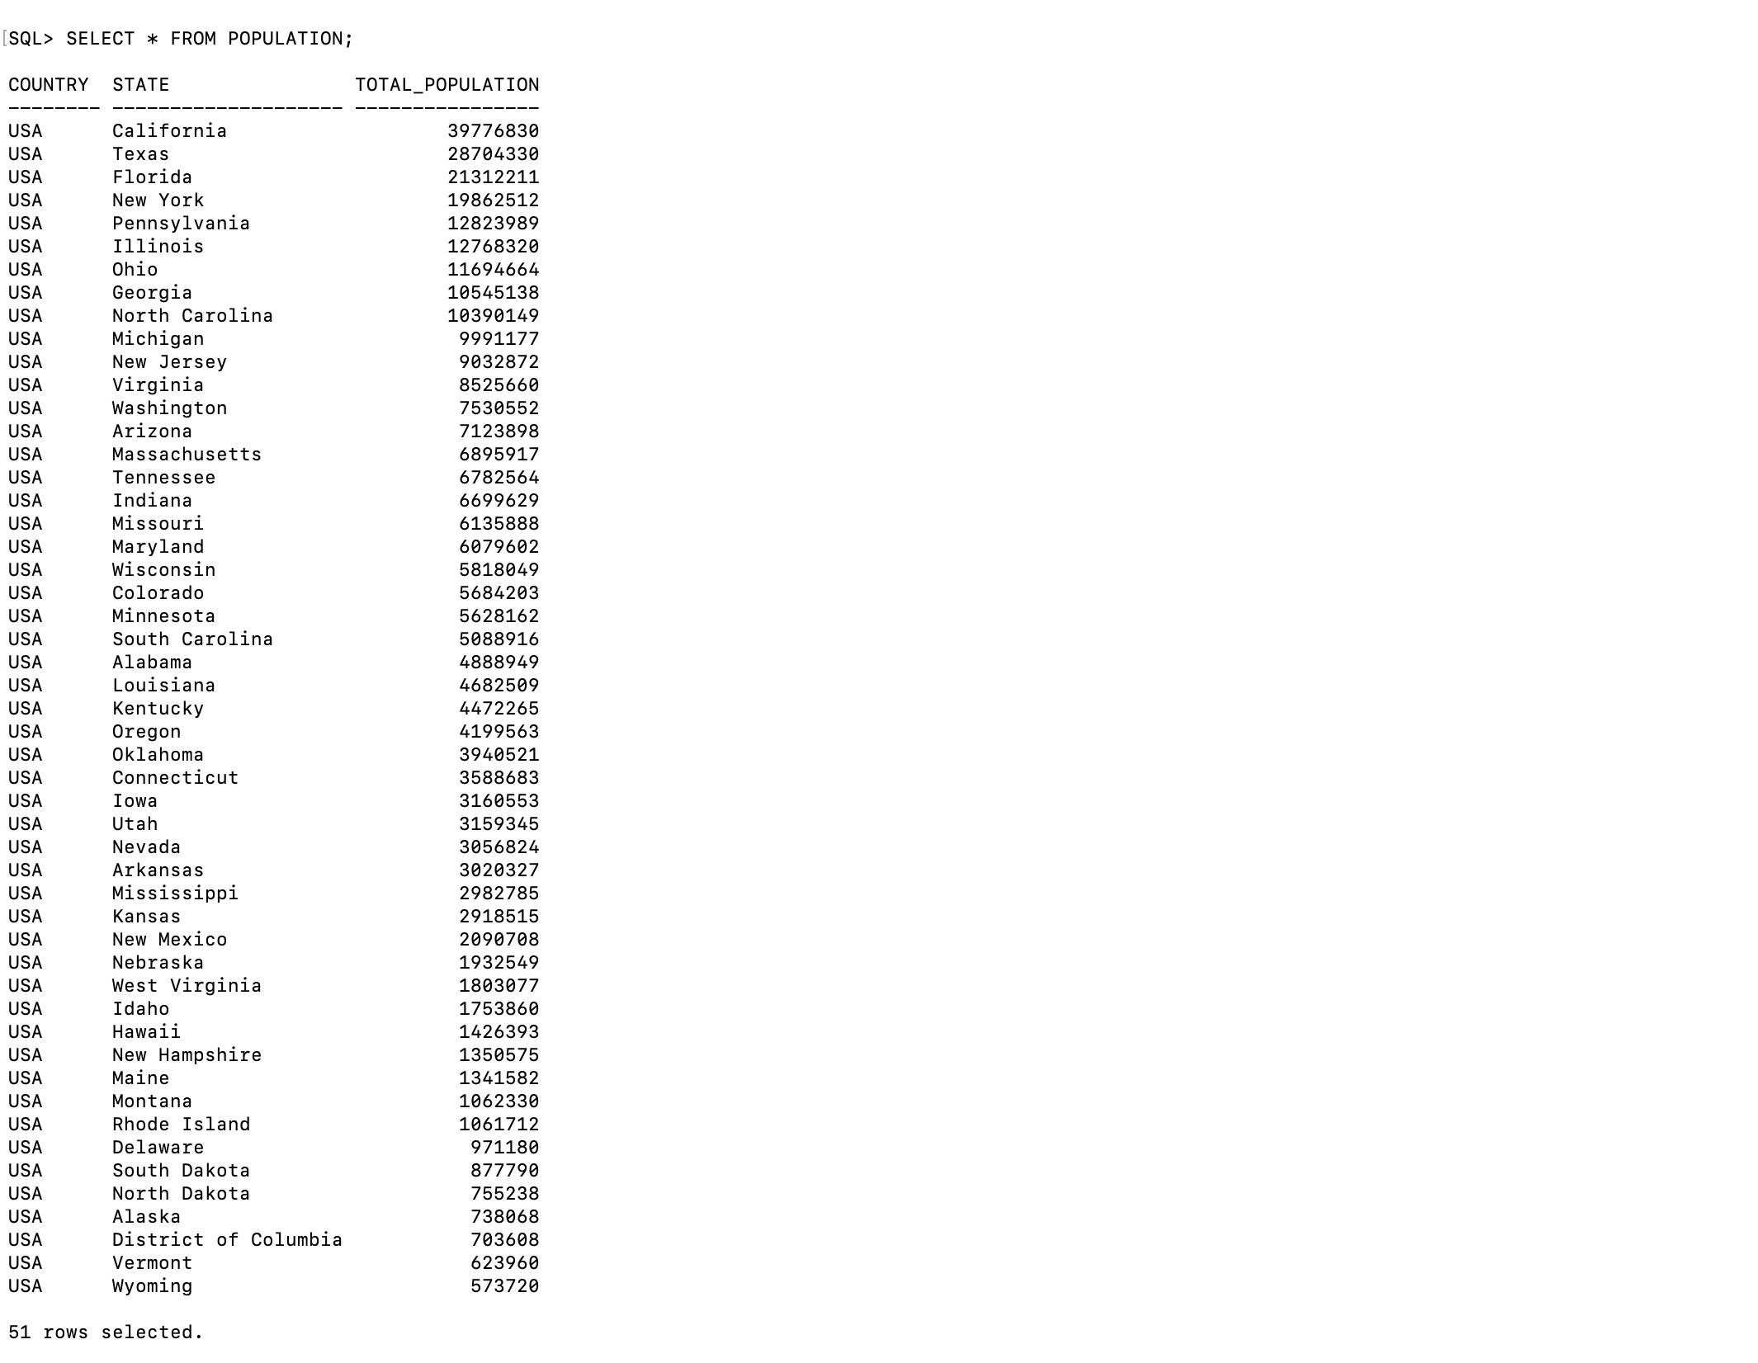

**Immigration Table**

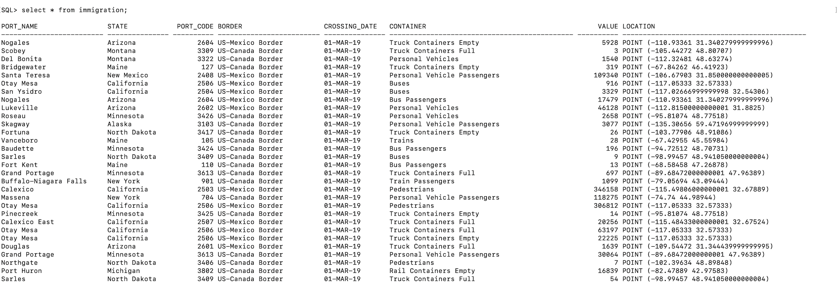

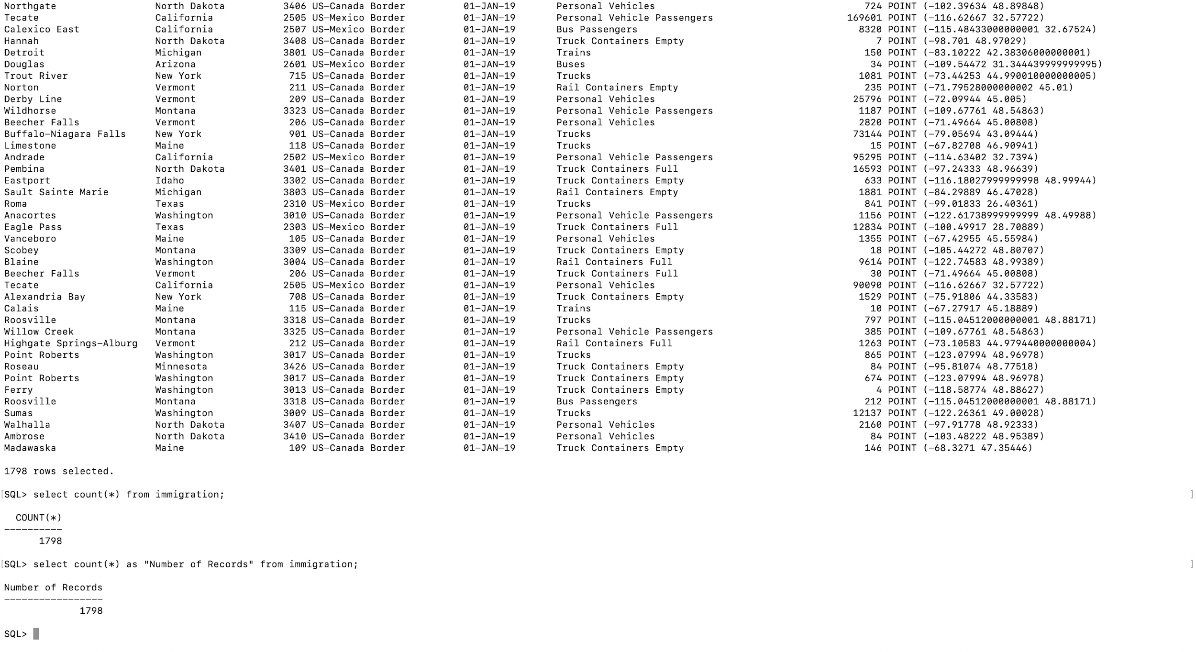

**Income Table**

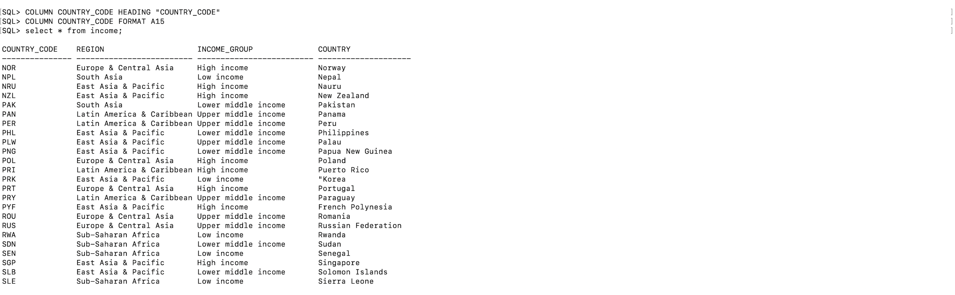

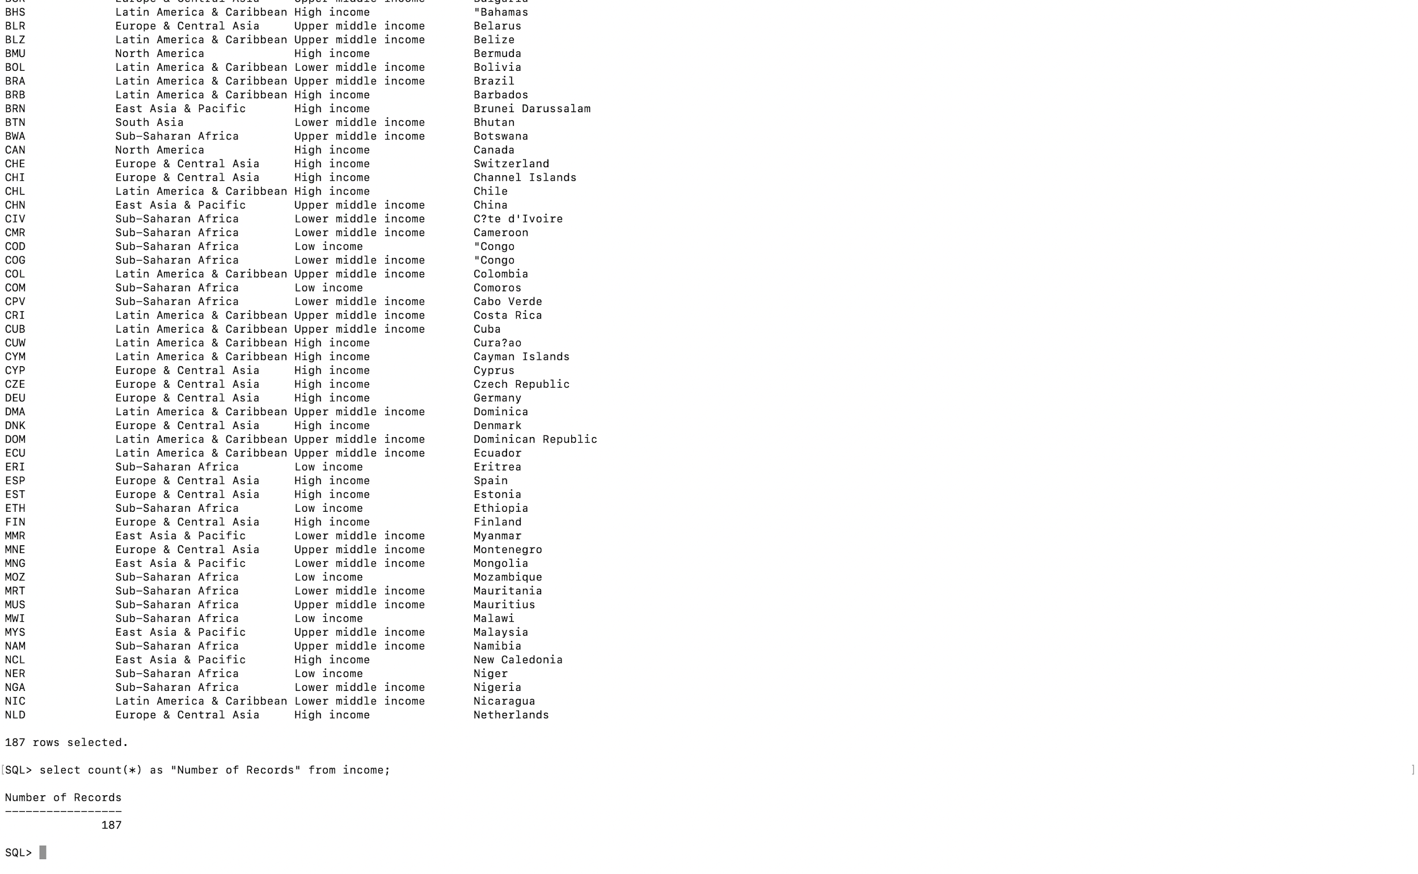

**Product Table**

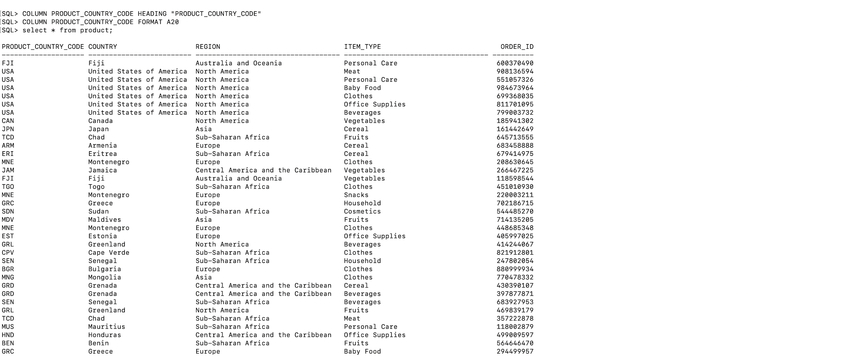

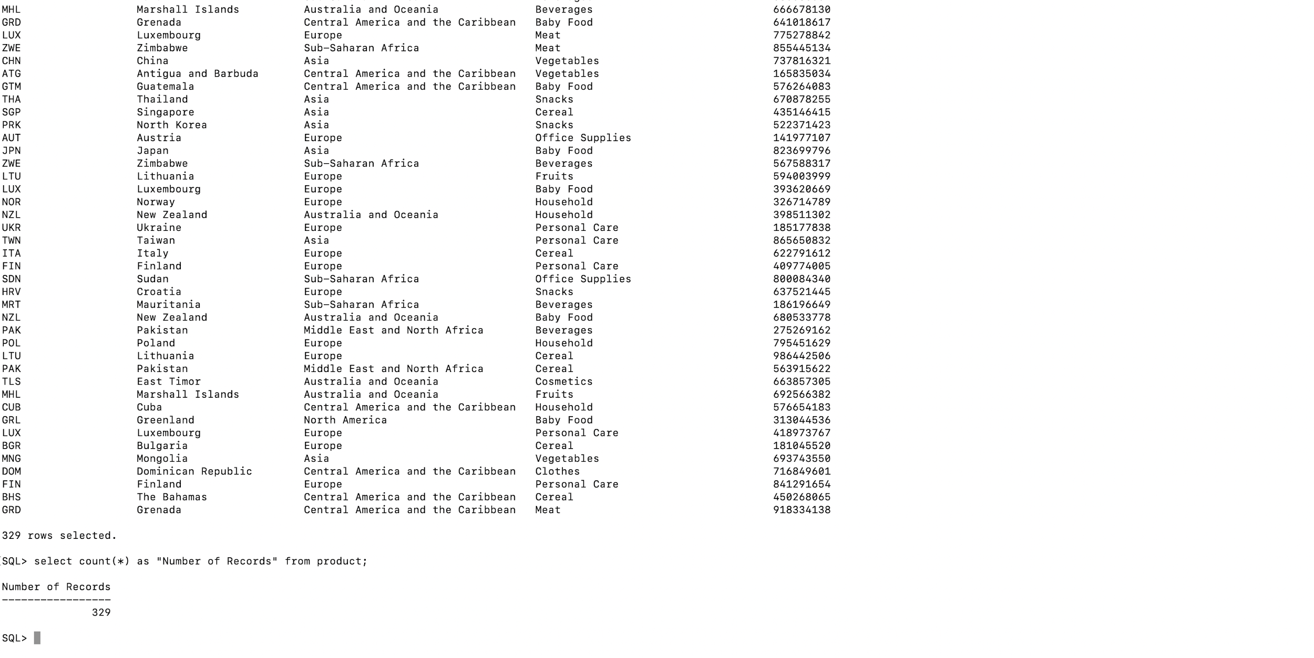

**Poverty Table**

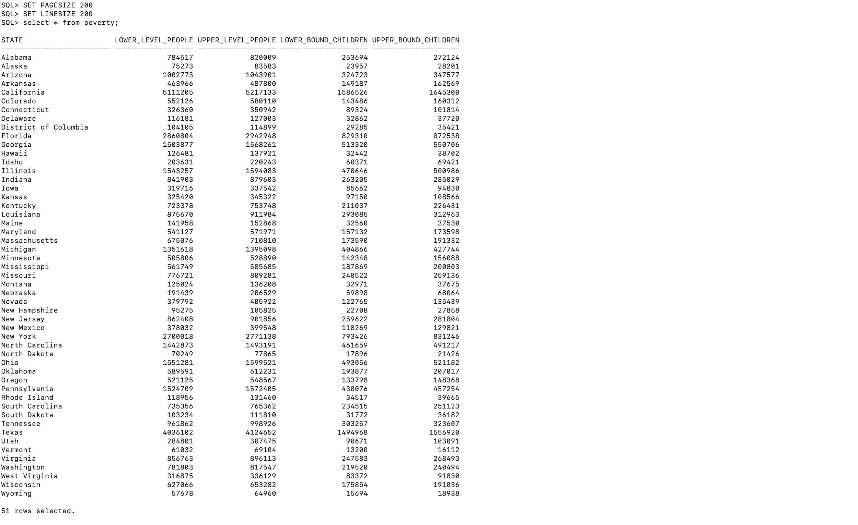

**Part 1: Oracle SQL Commands**

We have used **Phase 1 Queries** to answer these questions.

**1. How many people crossed the US border between the year 2018-2019?**

Answer:The total number of vehicles that crossed the US border between the year 2018-2019 are **6890229**.

*With the help of the aggregate function,* ***GROUP BY*** *and* ***INNER JOIN****, we get the final result*



**2. How many people are below the poverty line in every state of the US?**

Answer: The column “lower_level_people” shows **people under the poverty line** and column “lower_bound_children” shows **children under the poverty line**.

*The following query is used for the analysis of* ***people under the poverty line*** *vs* ***total population*** *in every state of US*

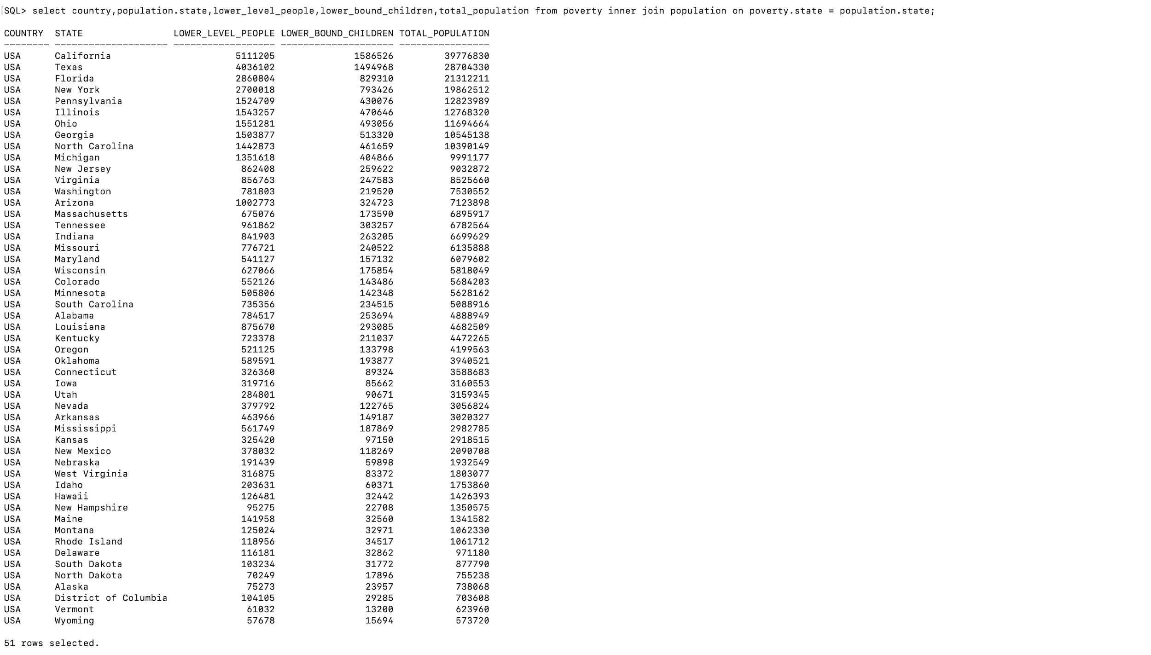

**3. How many countries lie under a high Income group?**

Answer: **64 Countries** lie under a high income group.

*We get the number of countries in a high income group by* ***cutting the Income table horizontally*** *with filtering countries in the high income group and then summarizing the records from the Income table by their income groups.* We used the following query to solve this question:



**4. Name the top 5 richest states in the US.**

Answer: **California, Texas, Florida, New York, Georgia**

We solve this question by using Complex Query: JOIN with TWO SUBQUERIES

Columns determining the result:

**Upper_level_people : Shows Number of People above poverty line;**

**Upper_Bound_Children : Shows Number of Children above poverty line;**

*First we sorted all the US states by number of upper level people and upper bound children in descending order by using* ***join*** *and a* ***subquery****.*

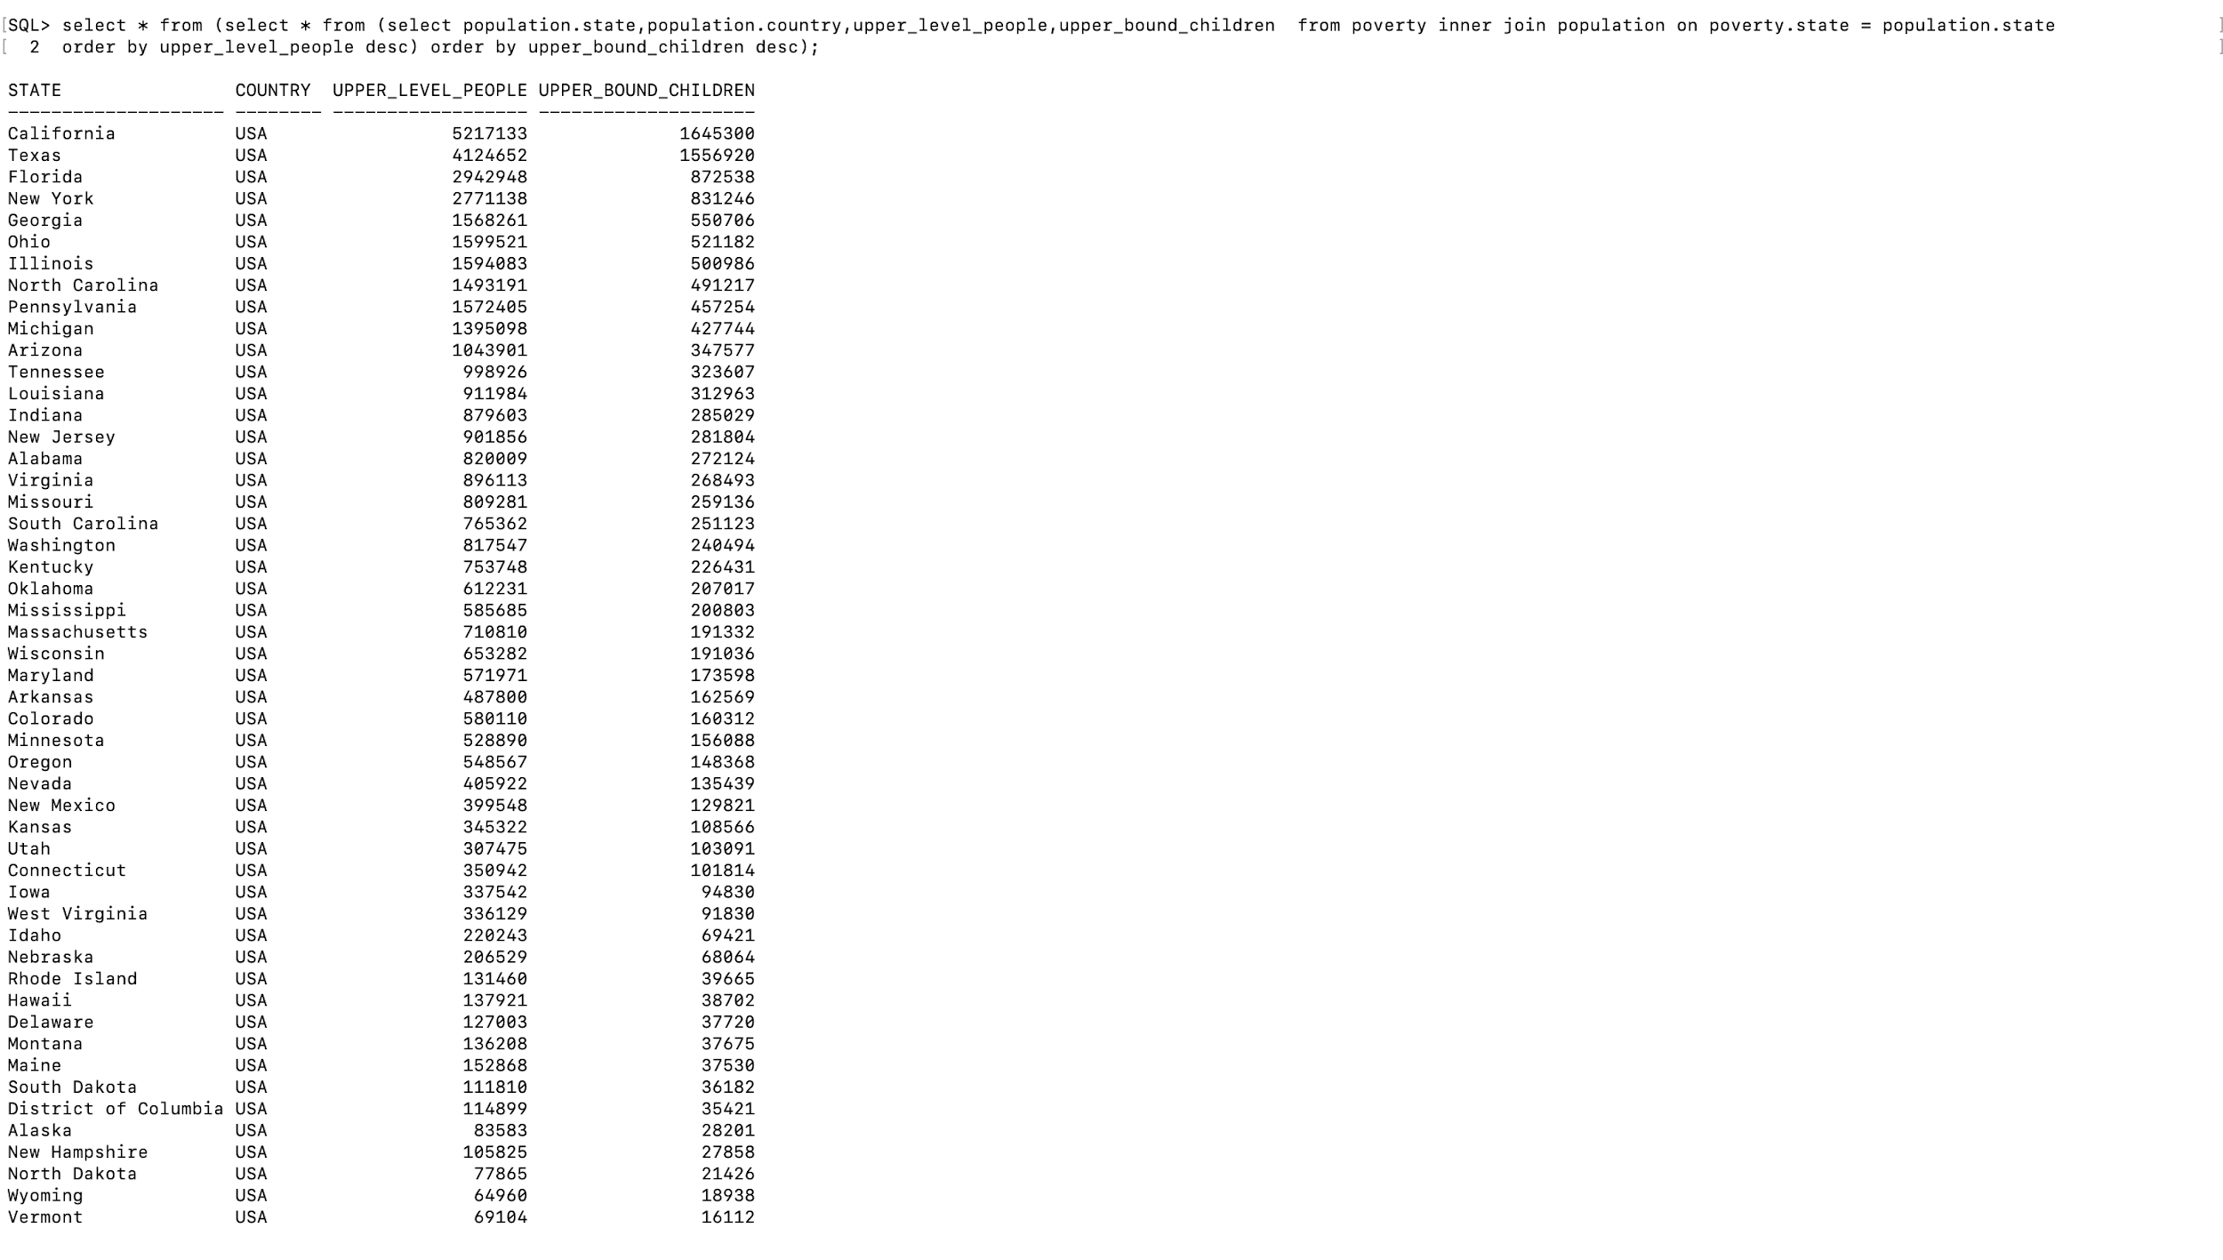

Secondly, we used another **subquery** and **rownum** on the above shown result to get top 5 records and hence we get the top richest states in the US.

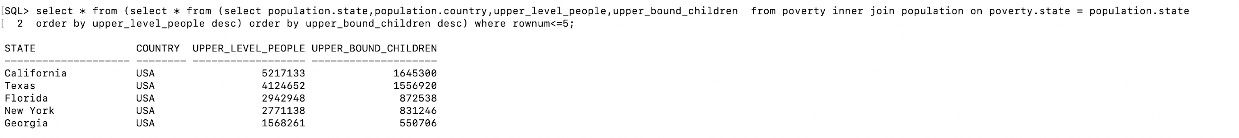

**Assumption**: The richer states are the ones which have more people and children above the poverty line than states which have a lesser number of people and children above the poverty line . We have ignored the number of people and children below the poverty line in comparison.

**Steps for Creating an index on table Product for a faster lookup:**

**We will choose column “Item Type” from product table for Indexing;**

**Number of records in Product Table having Item Type as “Meat”: 65**

**To view all indexes of a table, you query from the all_indexes view.:**

**Here the table product has 2 Indexes**

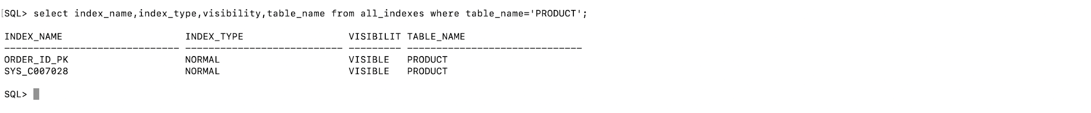

**Suppose, you often want to look up members by the last name and you find that the query is quite slow. To speed up the lookup, you create an index for the Item Type column:**

**You will see that the table Product has 3 Indexes now**

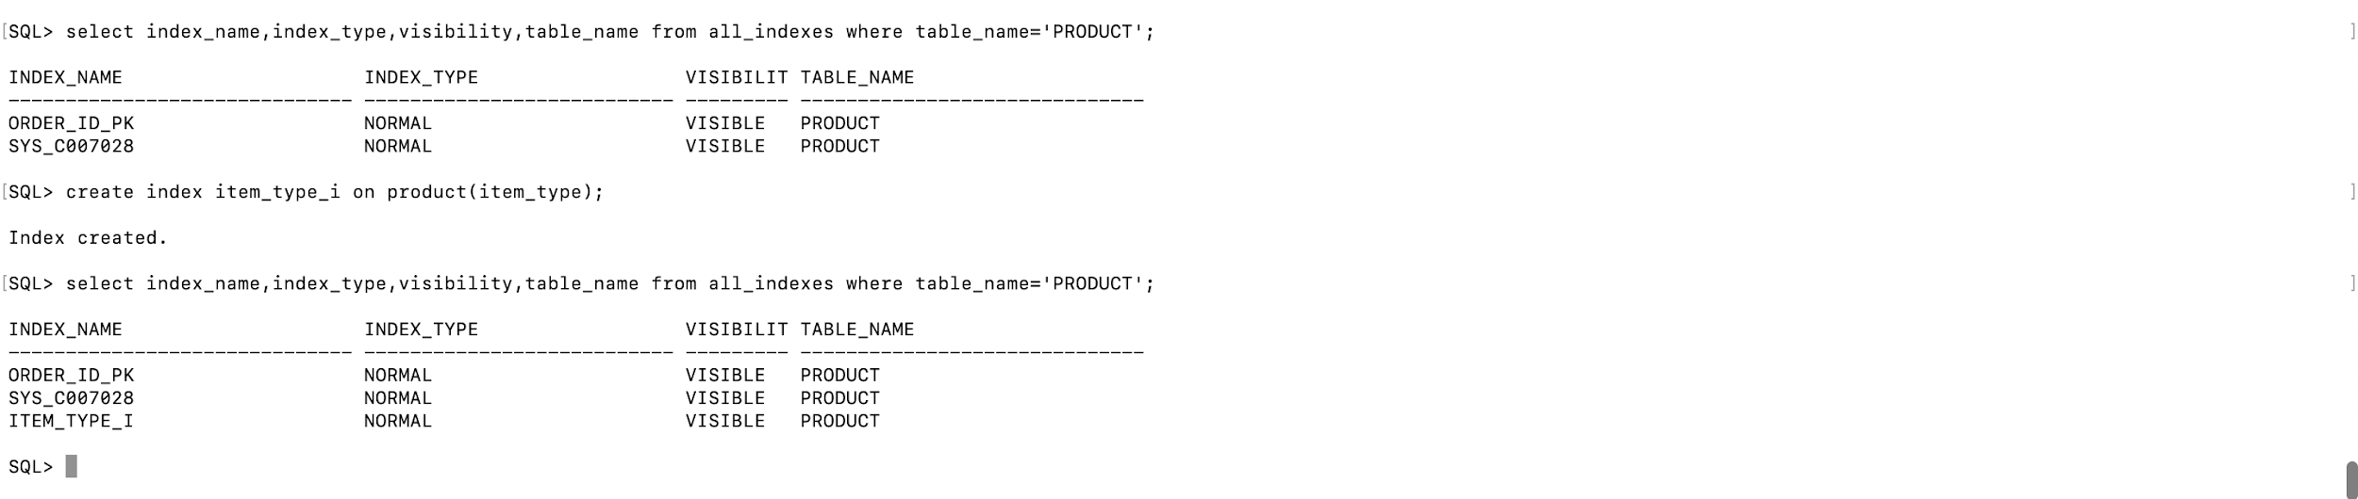

**The following statement finds products whose Item Type is Meat:**

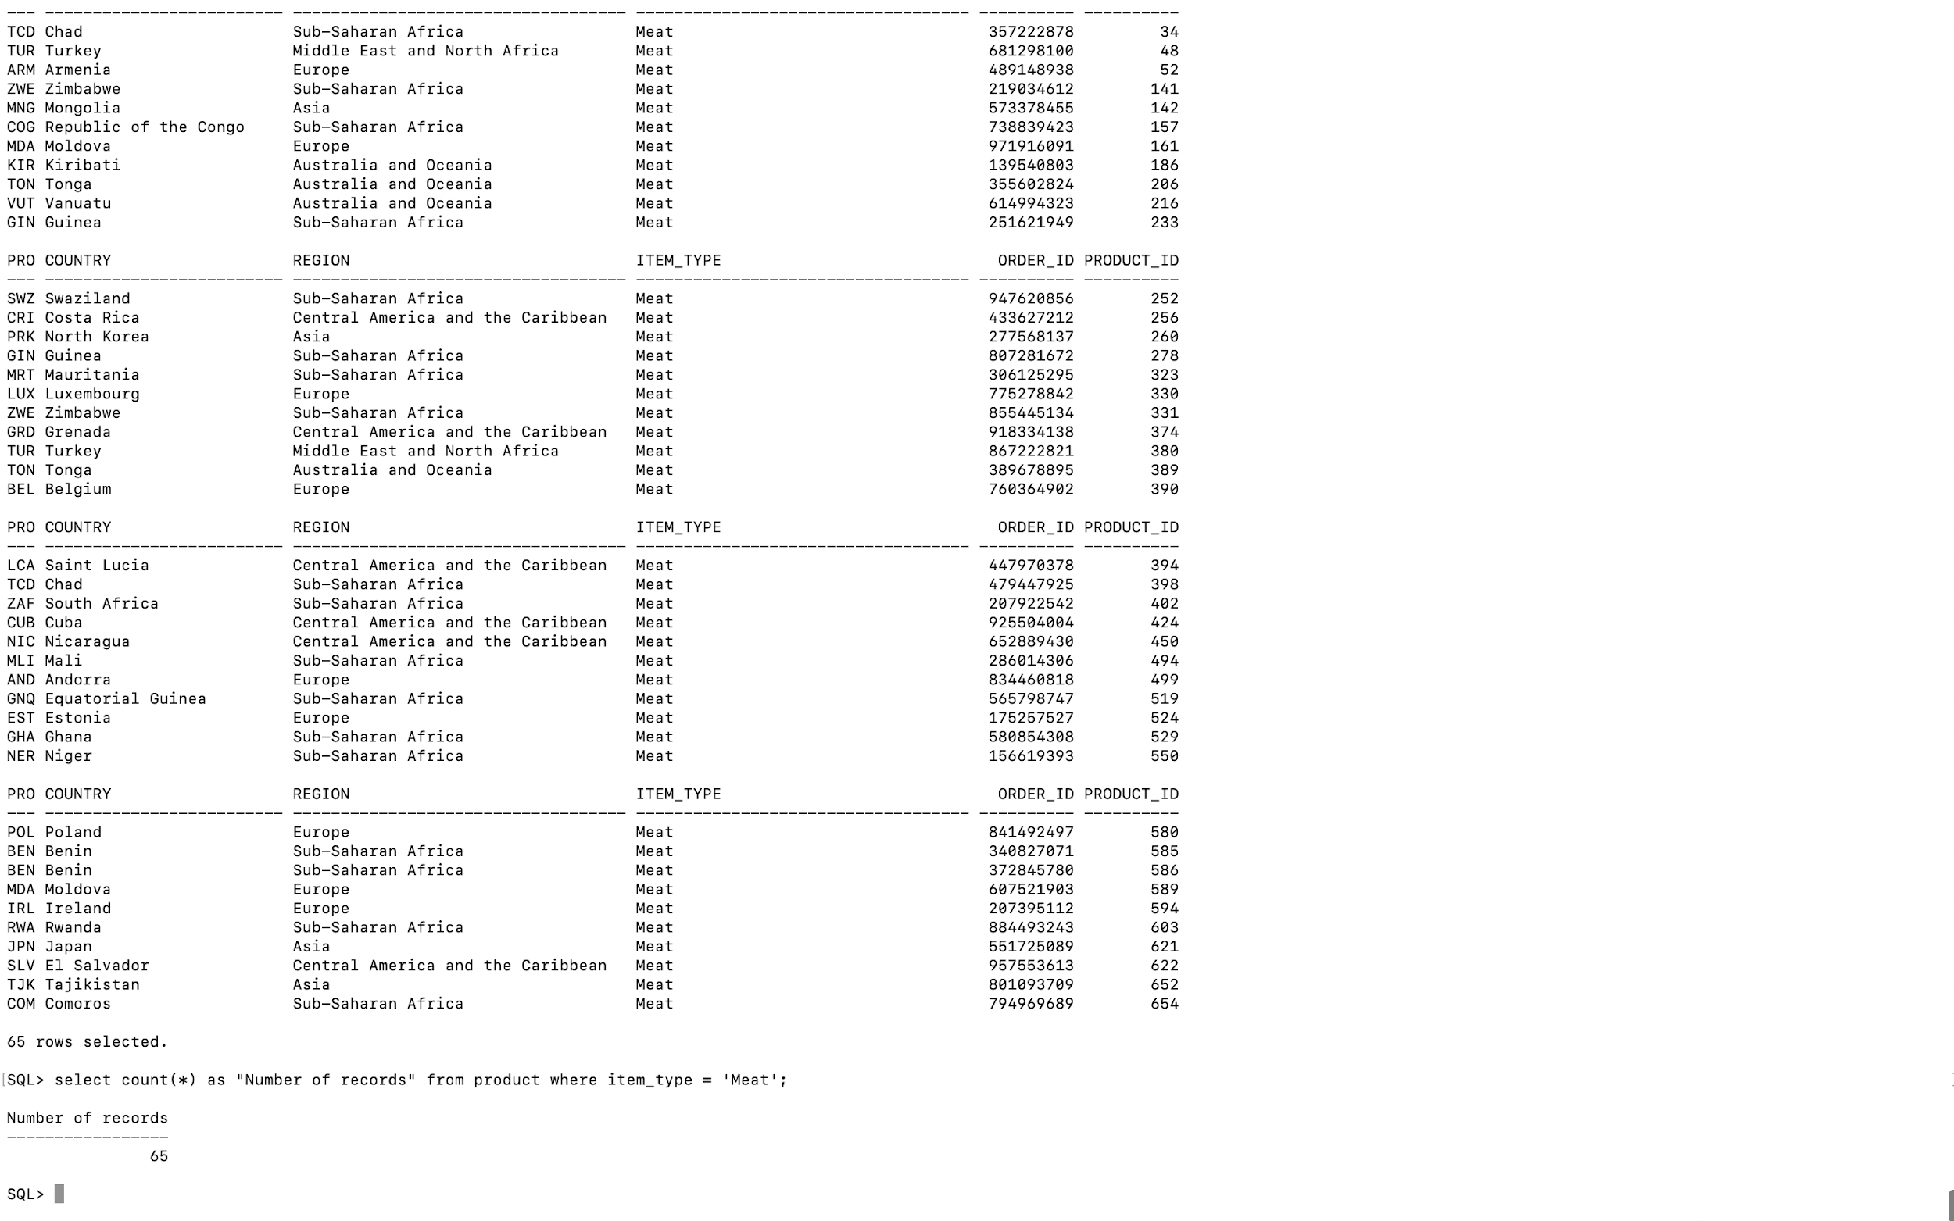

**To check if a query uses the index for lookup or not, we follow these steps:**

**First, add the EXPLAIN PLAN FOR clause immediately before the SQL statement:**



**This explains the execution plan into the plan_table table.**

**Then, use the DBMS_XPLAN.DISPLAY() procedure to show the content of the plan_table:**

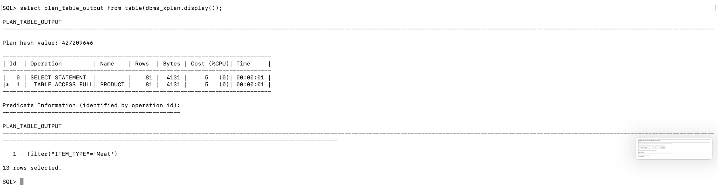

**You can see the number of rows are 13 here which are comparatively less to 65 earlier with filter “item_type” and value “Meat”.**

**Hence this way indexes make retrieval faster**

**PHASE 3 QUERIES**

**GROUP BY** WITH FILTER (Horizontal Cut)

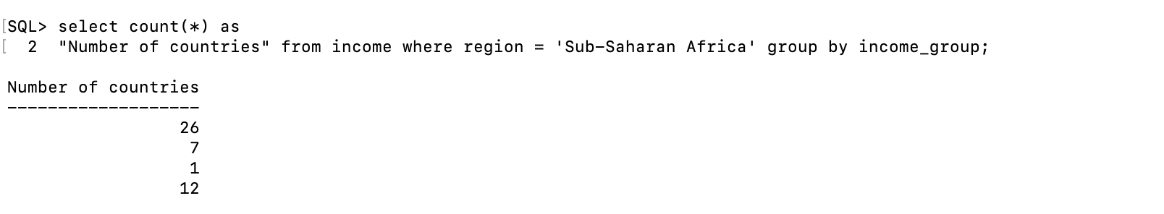

**INNER JOIN QUERY** WITH FILTER (Horizontal Cut)

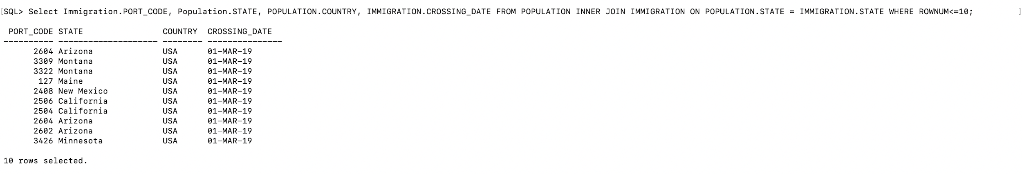

**Part 2. System Tables**

➤ The following is the system table for getting all tables, and the tablespace names by **user_tables**. The query we used is:

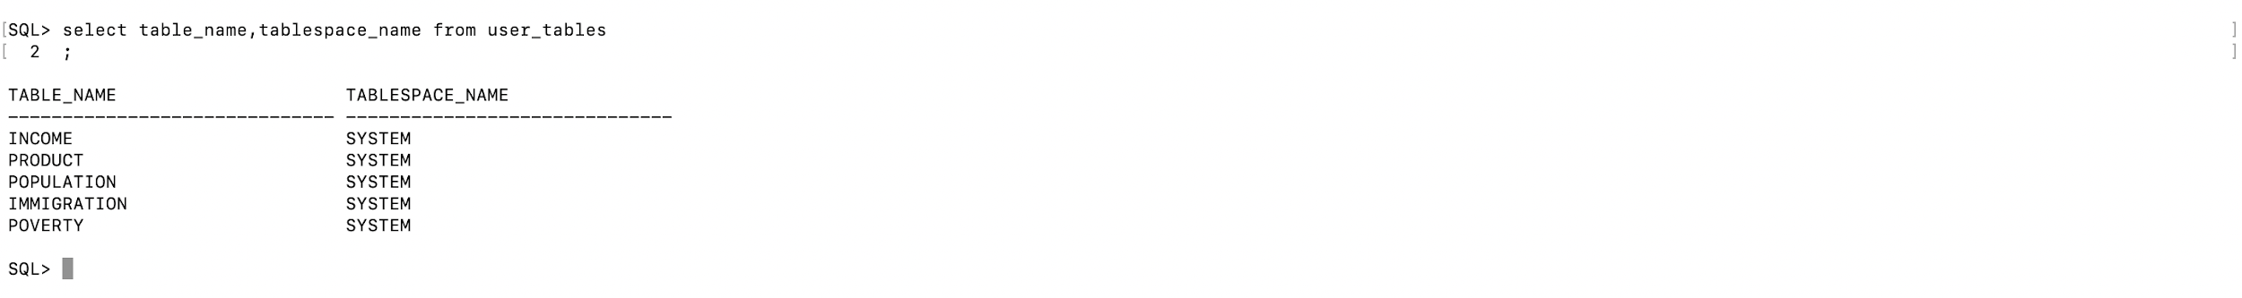

➤ The following is the system table for getting a description of relational tables which are accessible to the user by **all_tables**. The query we used is:

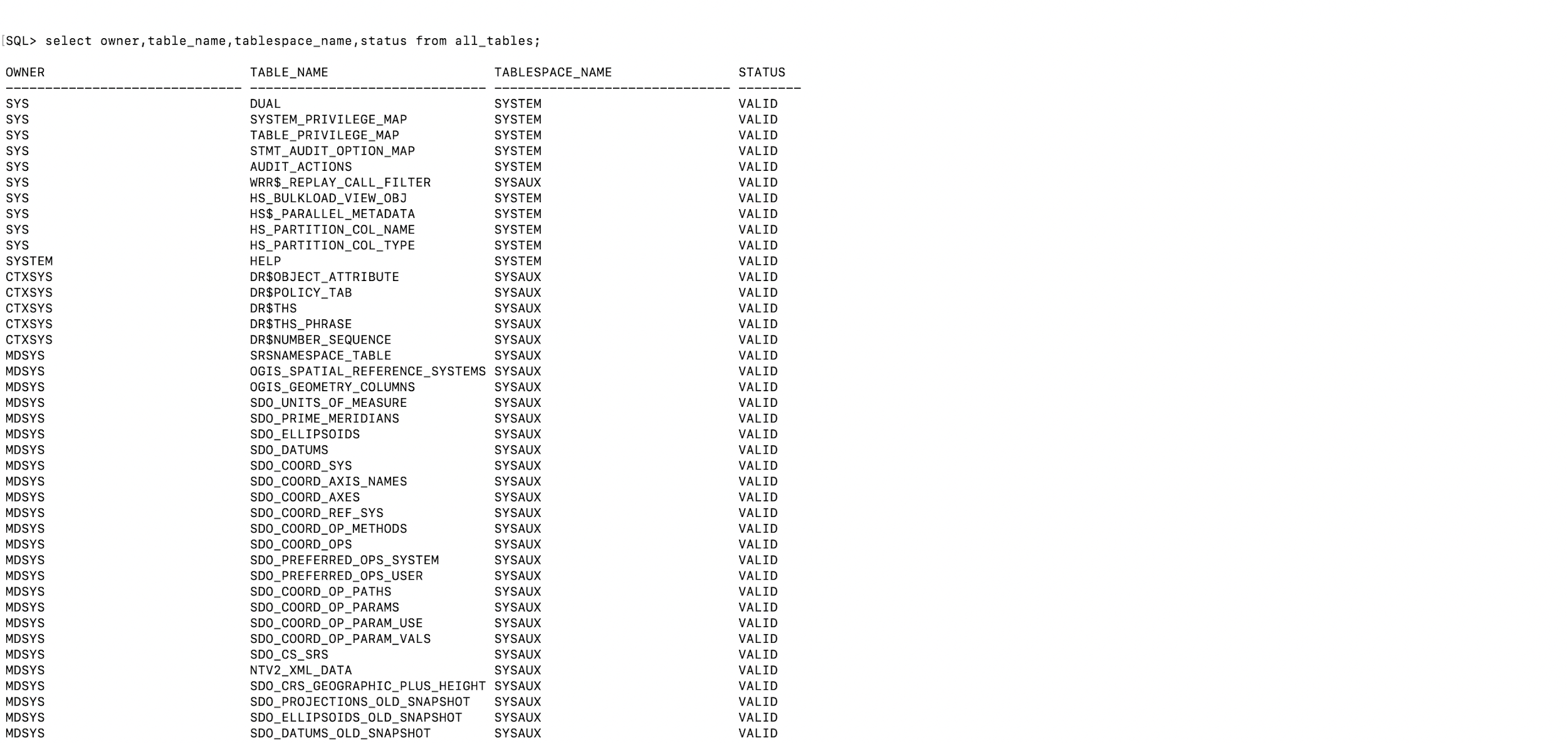 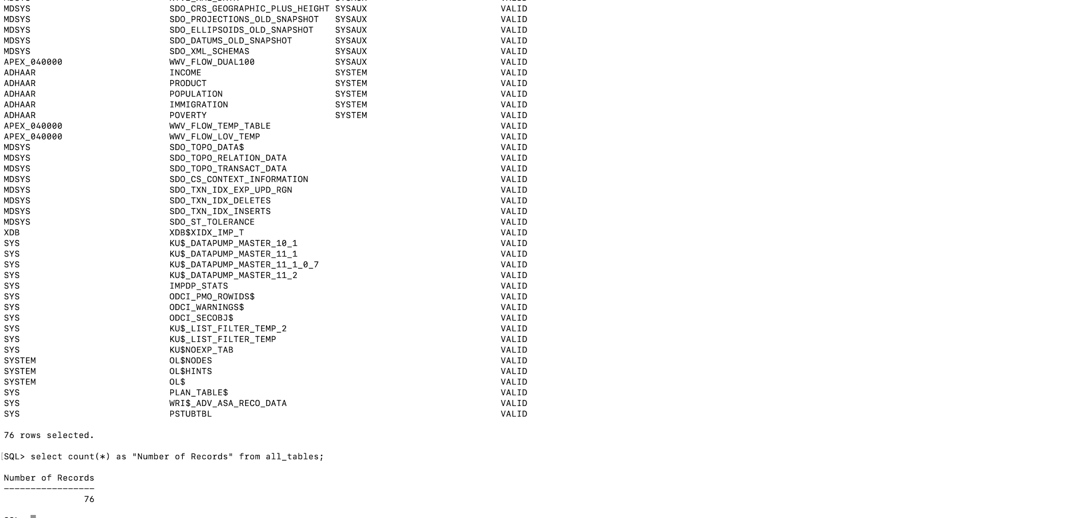

➤ The following is the system table for getting all information related to constraints by using **all_constraints.** The query we used is:

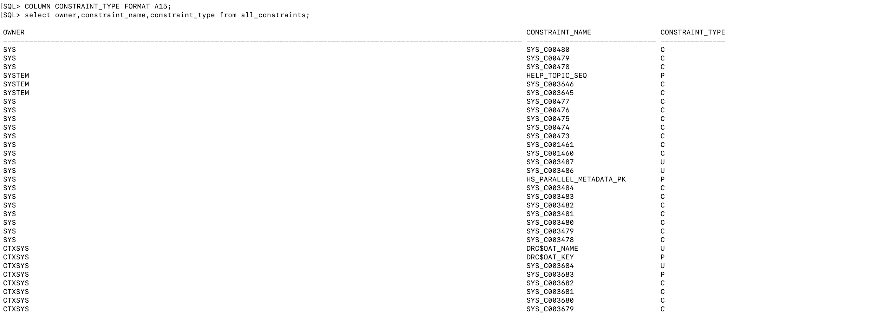

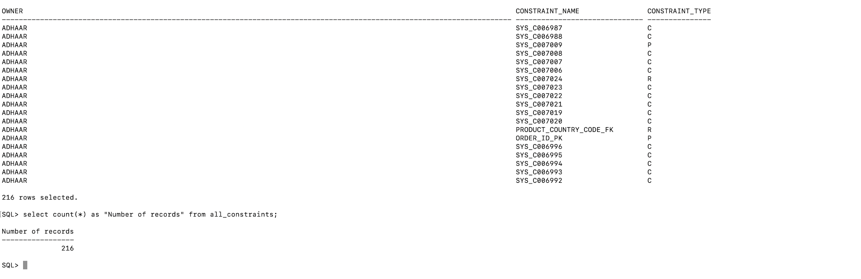

➤ The following is the system table for getting constraint definitions on tables in the current user's schema: **user_constraints**

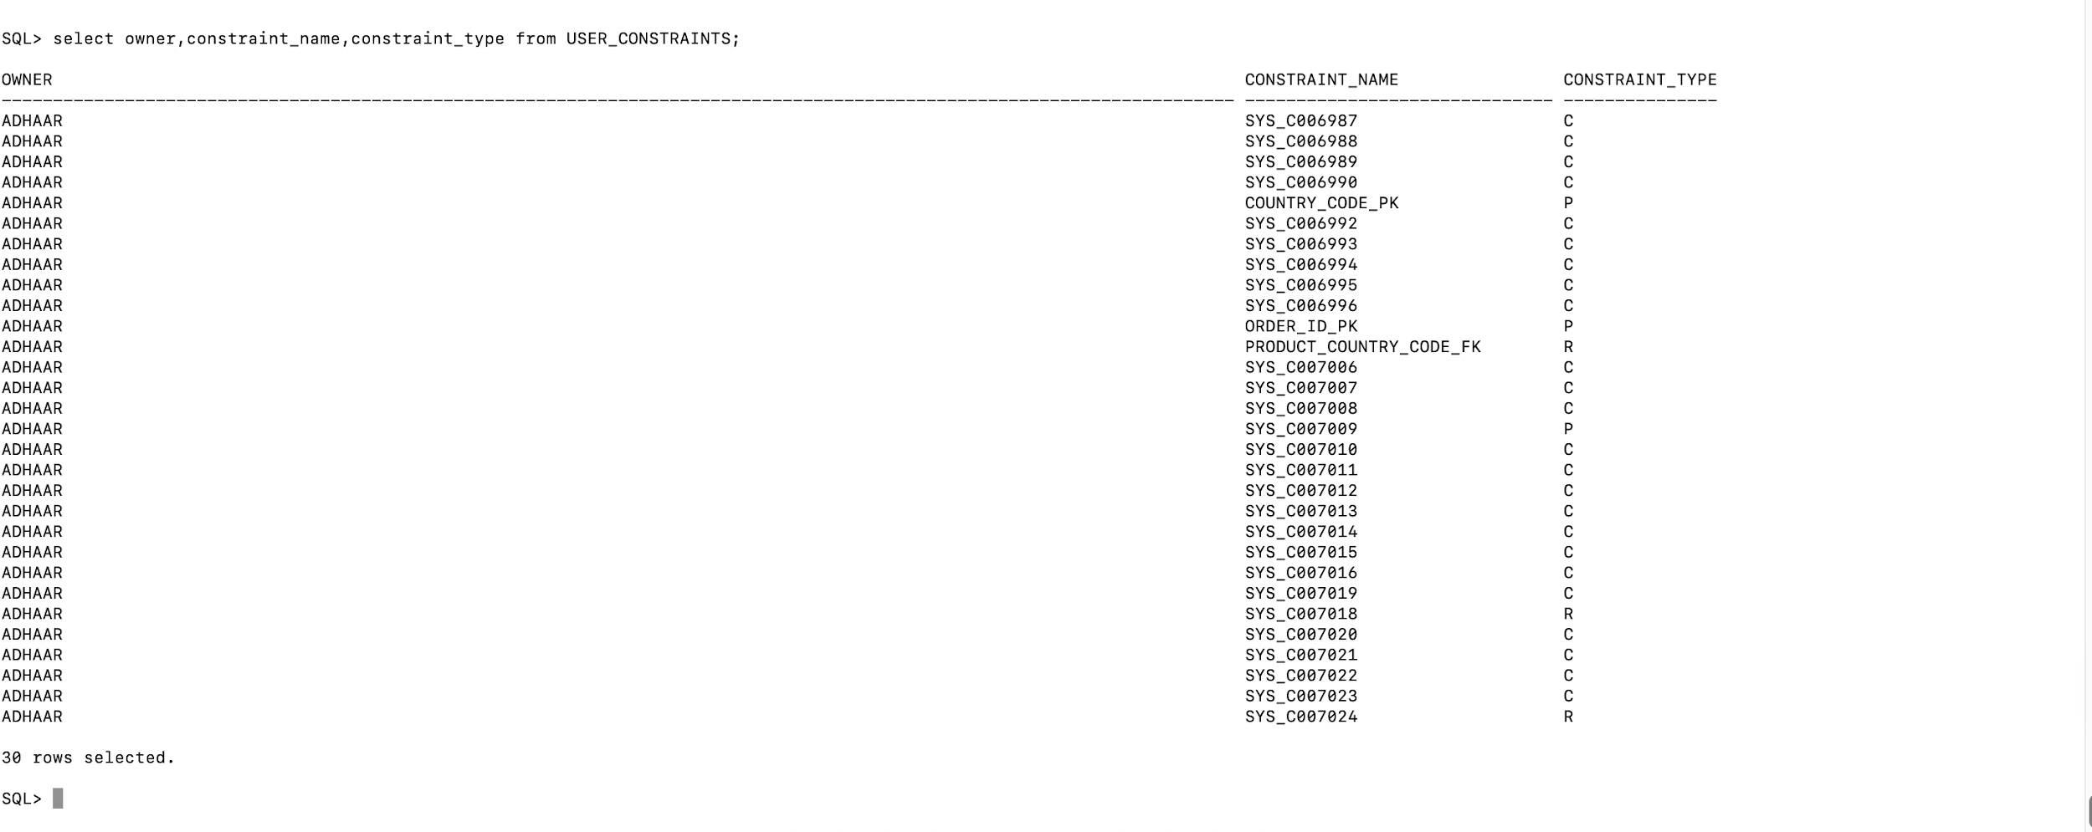

➤The following is the system table for getting privileges which the user currently has set under SESSION_PRIVS. The query we used is:

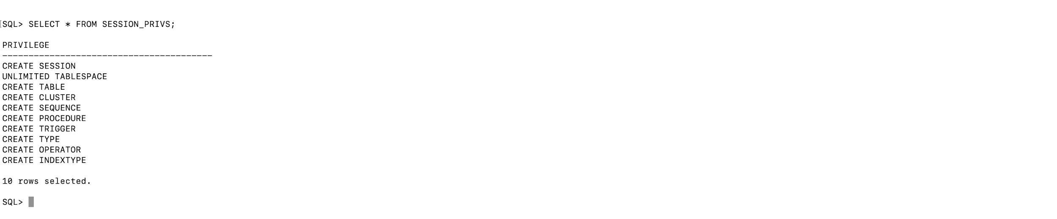

**Changing Degree of a Table**

Degree is defined as the number of threads per instance for scanning the table

**Before:** The degree of the table Poverty is 1

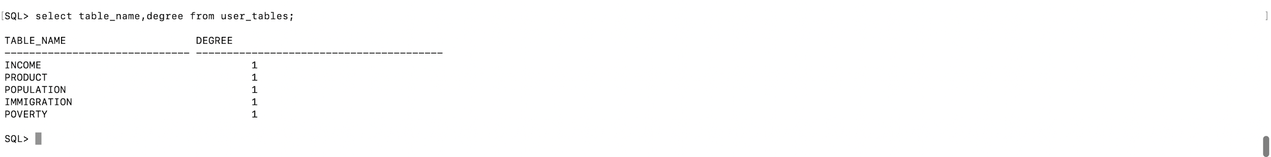

**After:** The degree of Table Poverty is 8

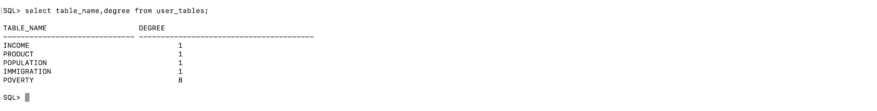

**Deleting entry from constraints table**

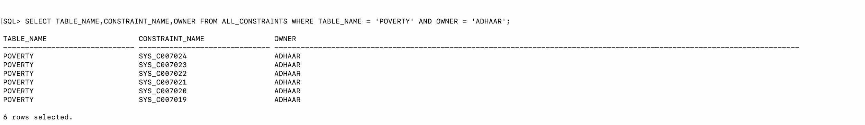

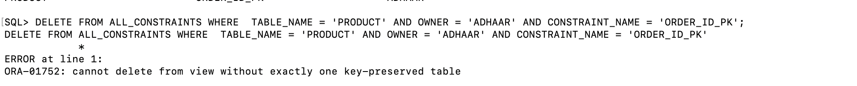

**Part 3: Schema Constraints**

CASCADE DELETE QUERIES:

Description:

Parent Table : Income

Primary Key : country_code

Child Table: Product

Foreign Key : product_country_code

Here product_country_code references country_code from parent table.

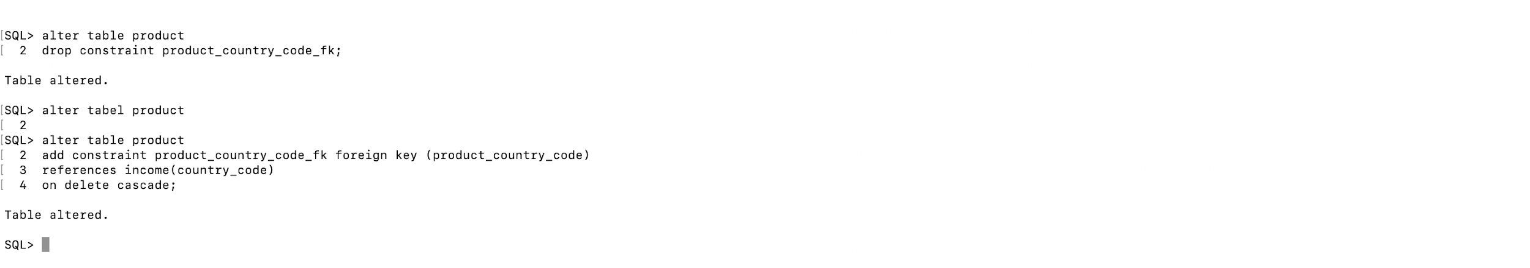

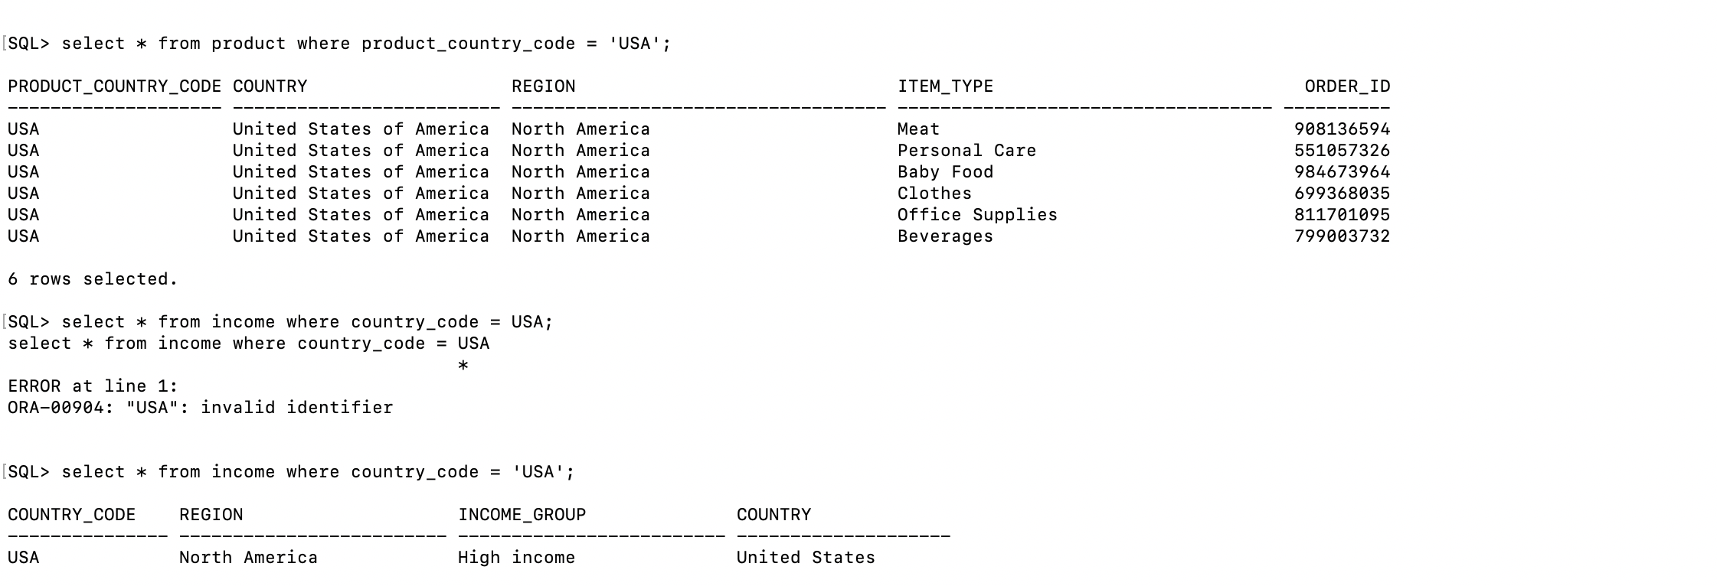

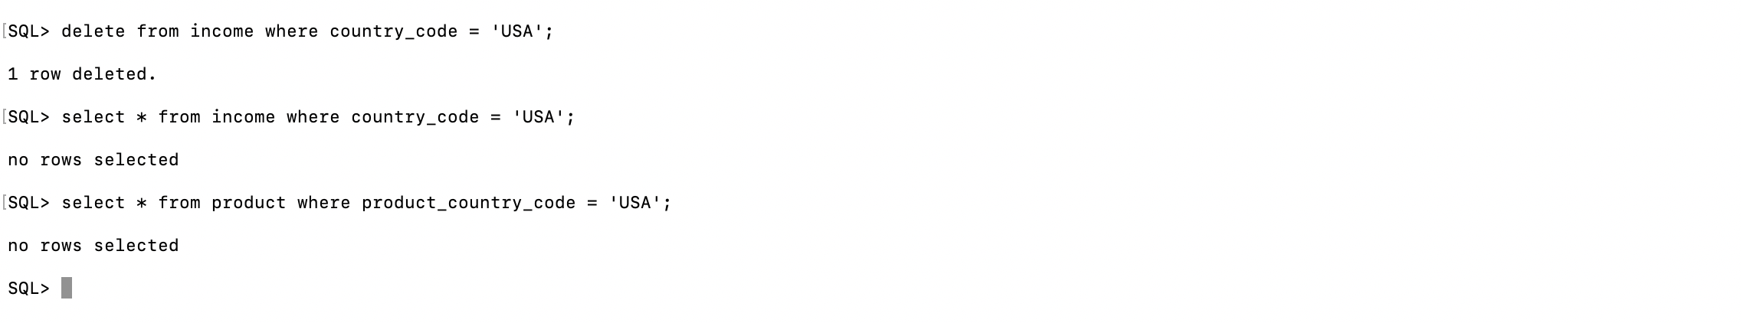

Here the columns deleted from parent table income have also deleted columns from child table product by delete cascade;

**Referential Integrity constraint violations:**

**Delete:** The income is parent table with country_code as primary key and product is child table with product_country_code as foreign key so deleting a record from parent table is a

violation



**Update:** The income is parent table with country_code as primary key and product is child table with product_country_code as foreign key so updating a record in parent table is a

violation

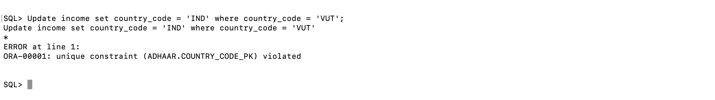

**Insert:** The income is parent table with country_code as primary key and product is child table with product_country_code as foreign key so inserting a record in child table with no corresponding entry in parent table is a violation

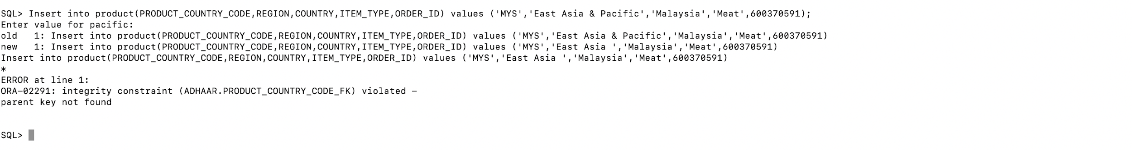

SET RESTRICT AND SET DEFAULT IS NOT SUPPORTED IN ORACLE 11g

Link - <http://www.dba-oracle.com/bk_on_delete_restrict_on_delete_no_action_tips.htm>

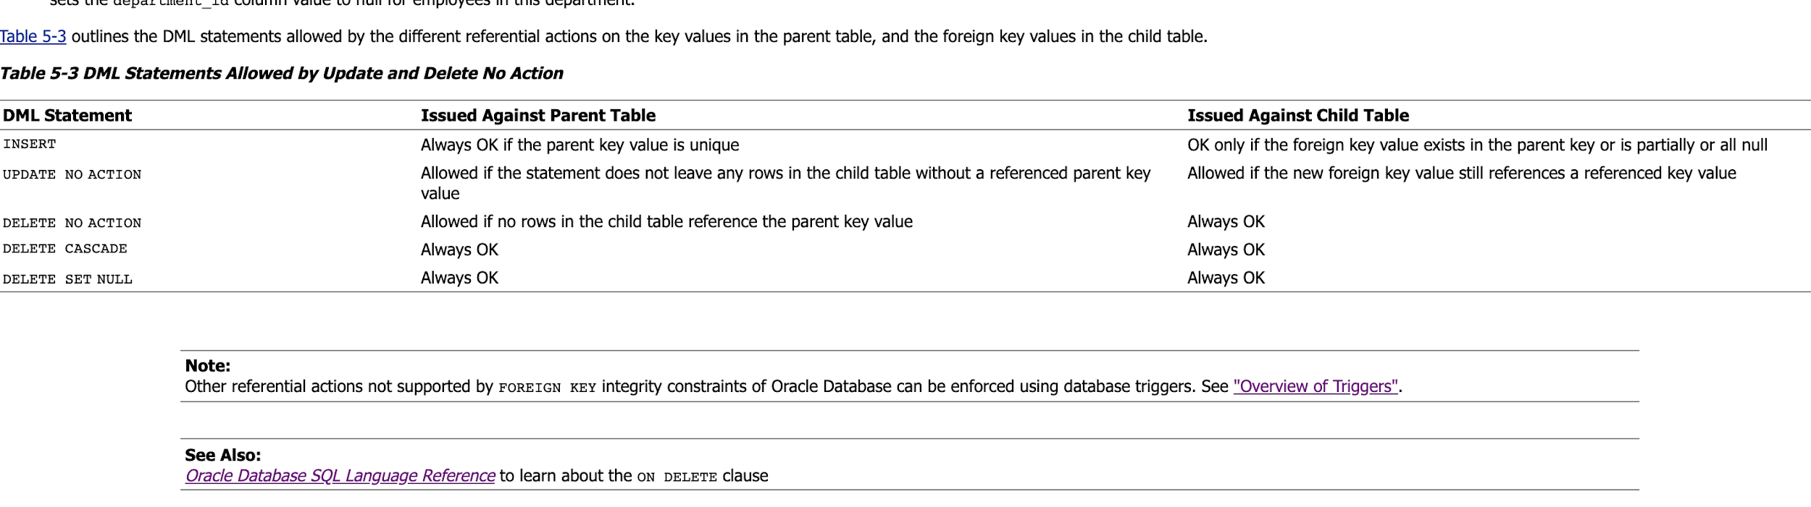

**Part 4: Oracle Sequence Object**

*To create Oracle Sequence objects we have to follow the following* **5 steps***:*

**Step 1**: Adding auto increment column “product_id” to the table product

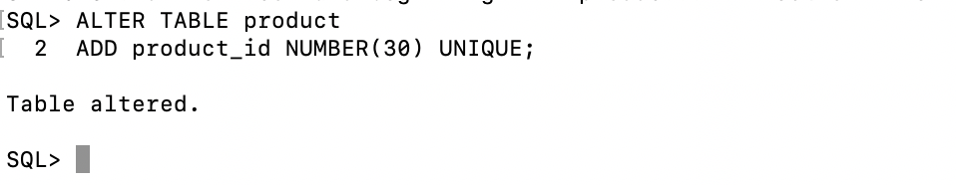

**Step 2**: Adding sequence object starting from 1

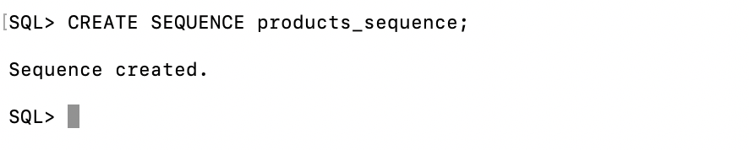

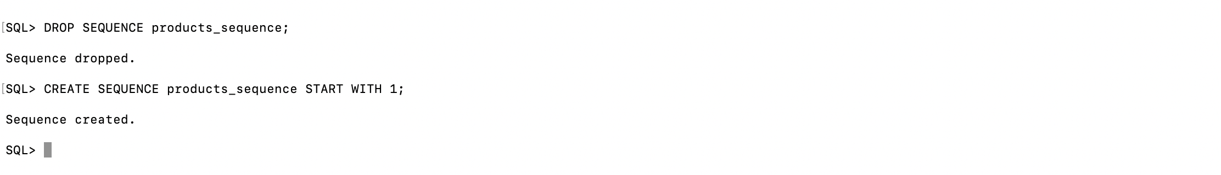

**Step 3**: Creating trigger on insert to table product so that auto increment values that can be added for column “product_id”.

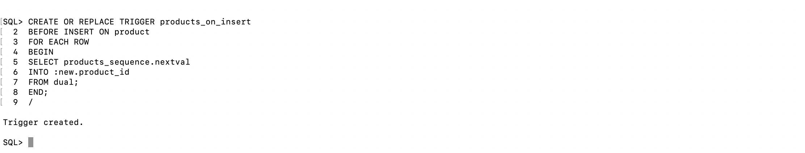

**Step 4**: Successful loading of csv into table product by using sql loader.

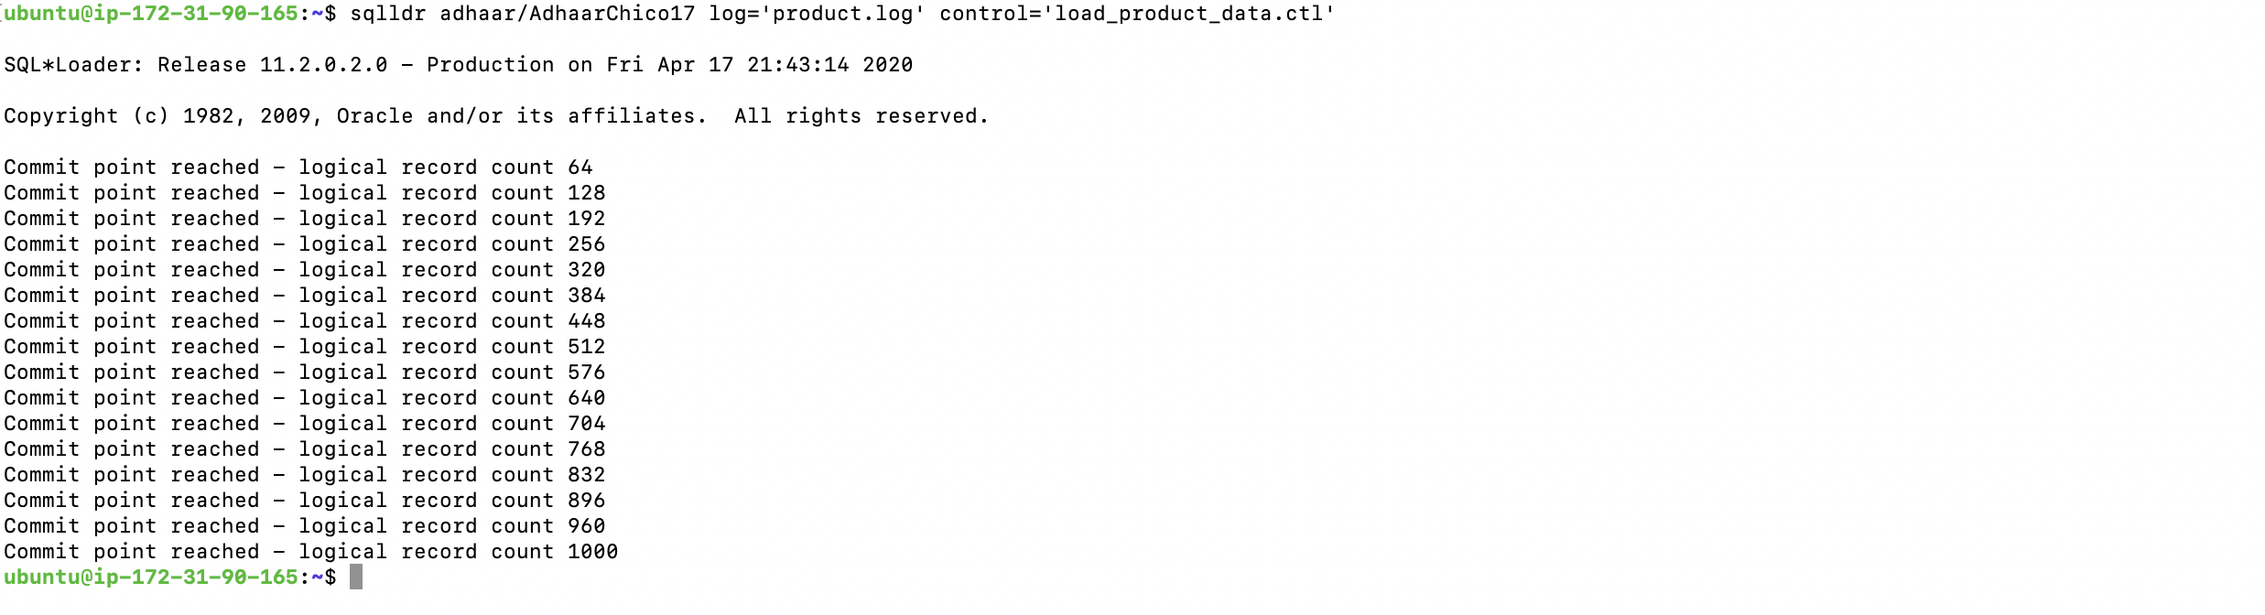

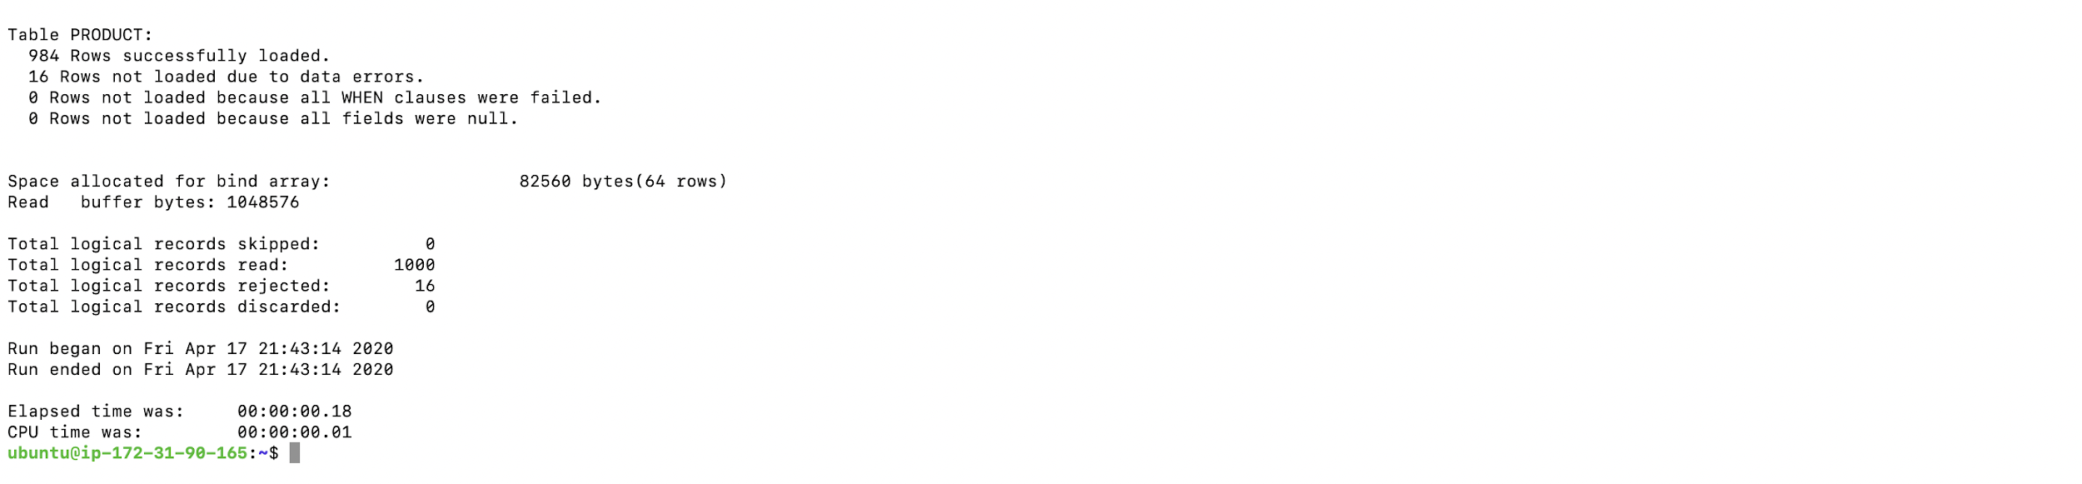

**Step 5**: Now you can see the auto increment values for column “product_id” starting from 1.

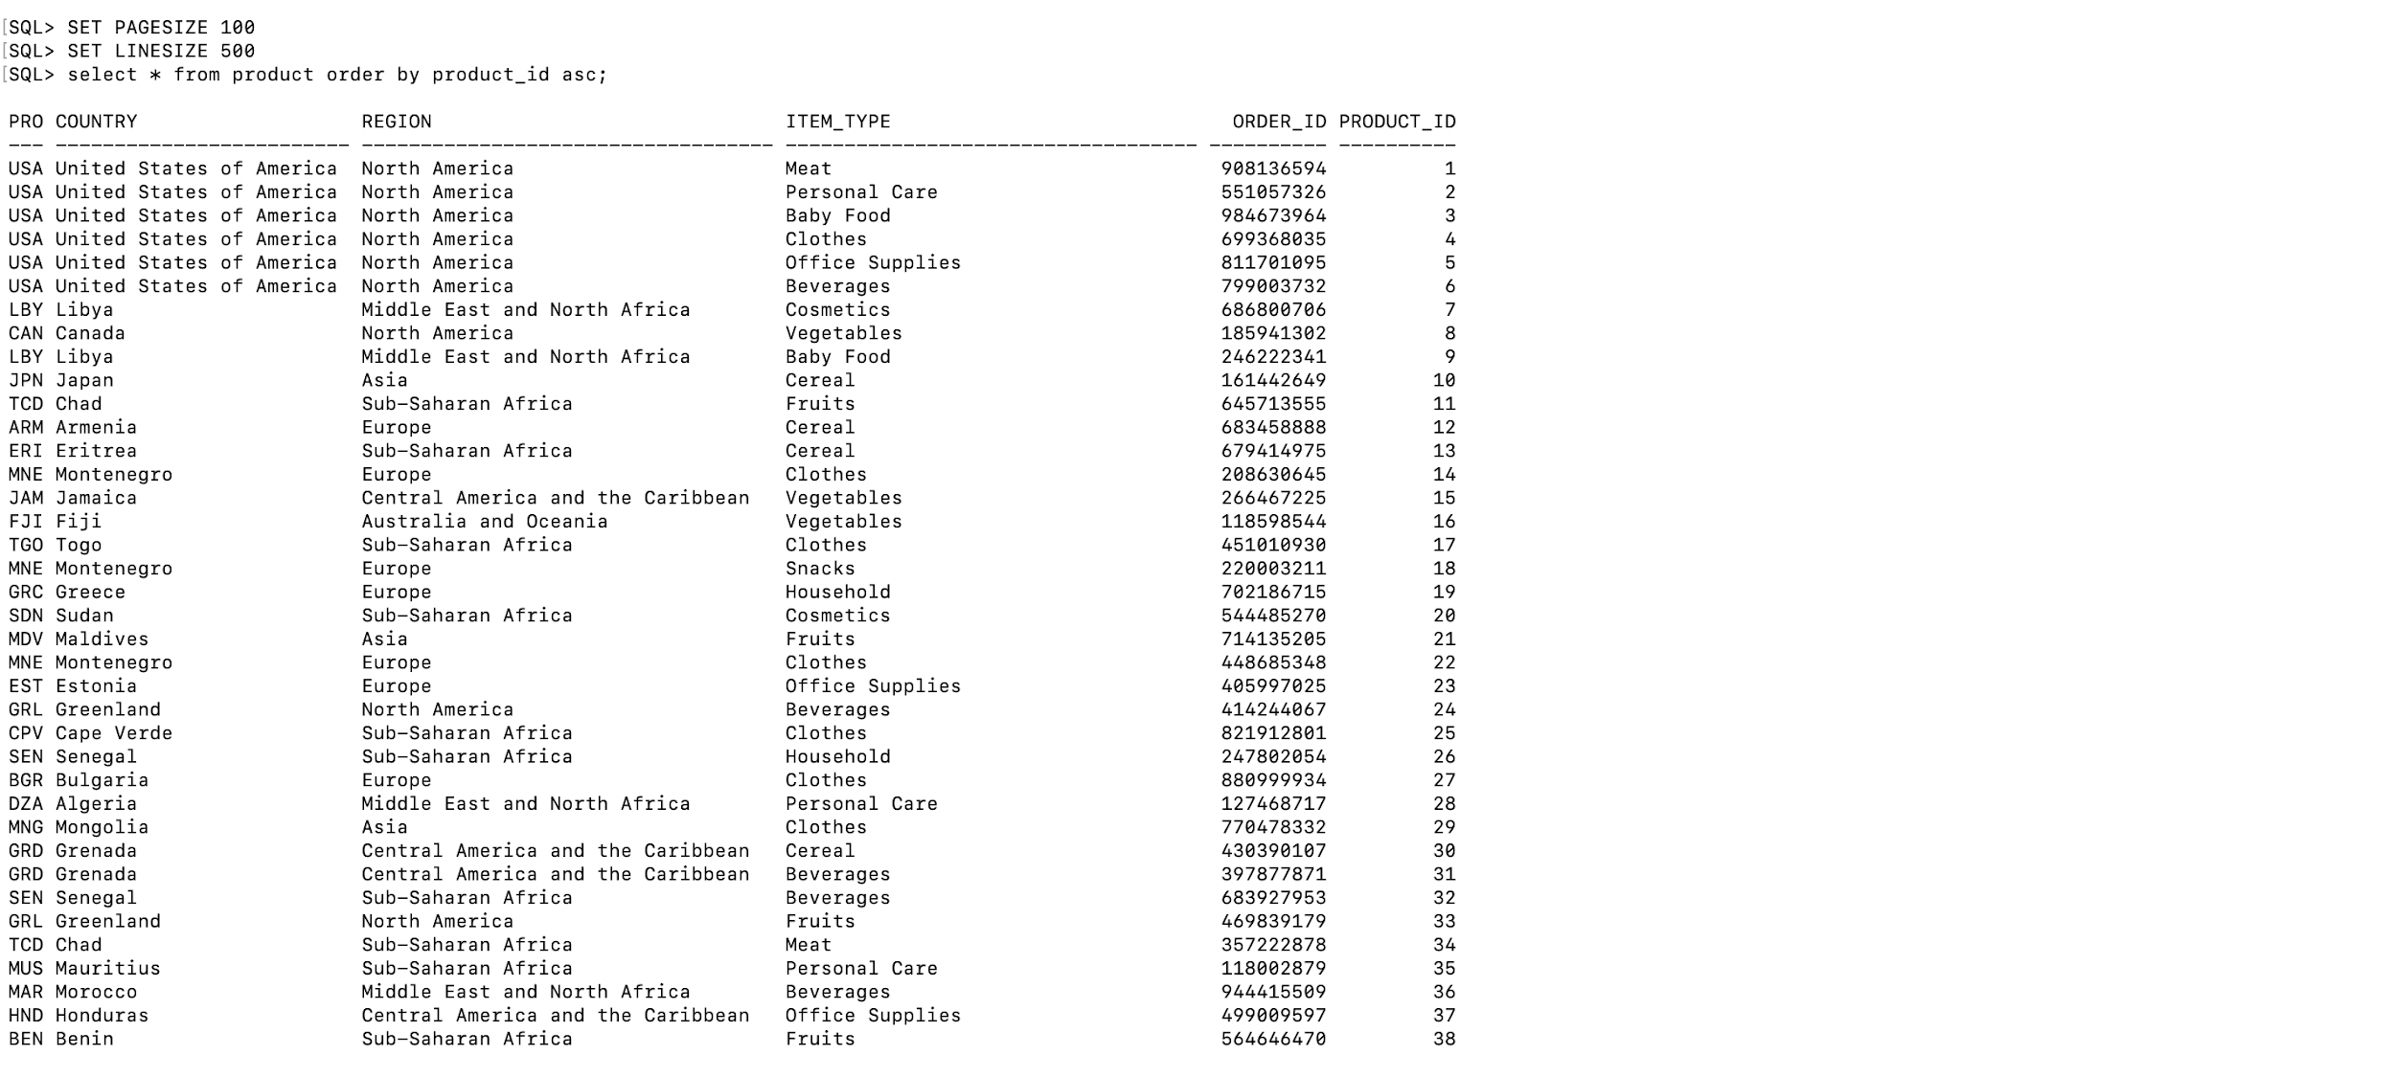

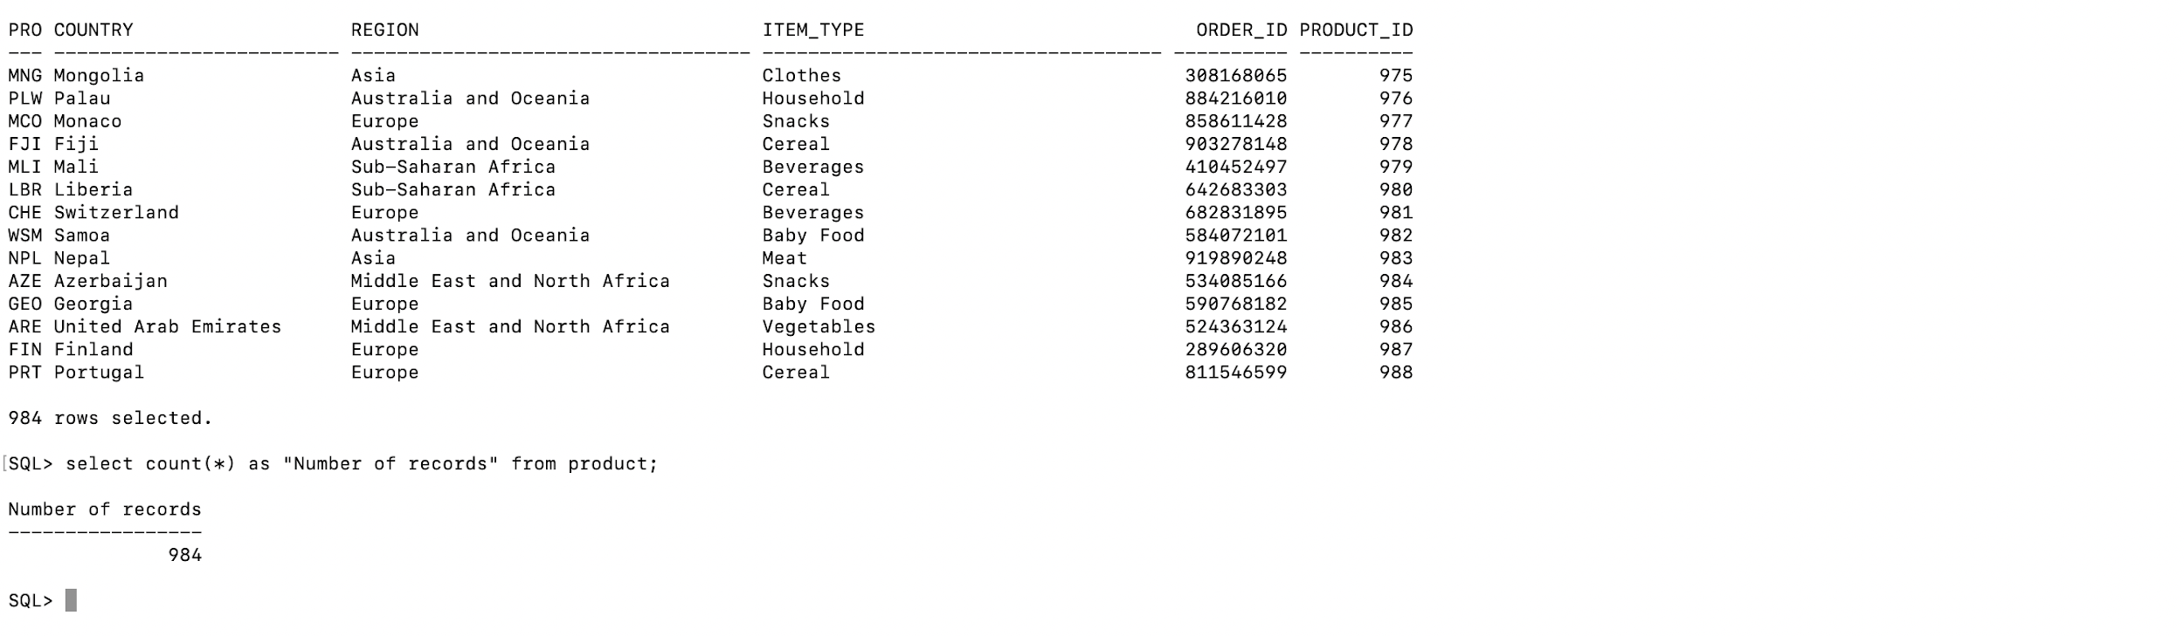

**Part 5: Multiple Database**

In this part we are implementing the access between multiple databases schemas by explaining the steps involved.

Tables of user : Adhaar

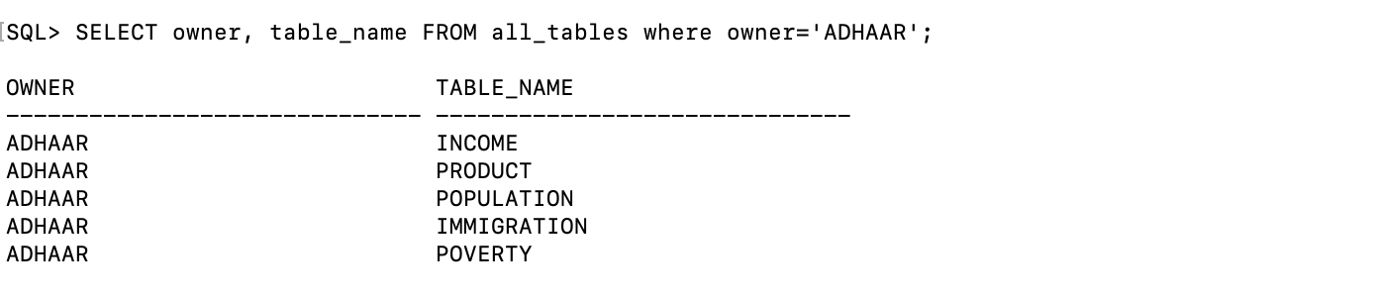

Created another user : testuser

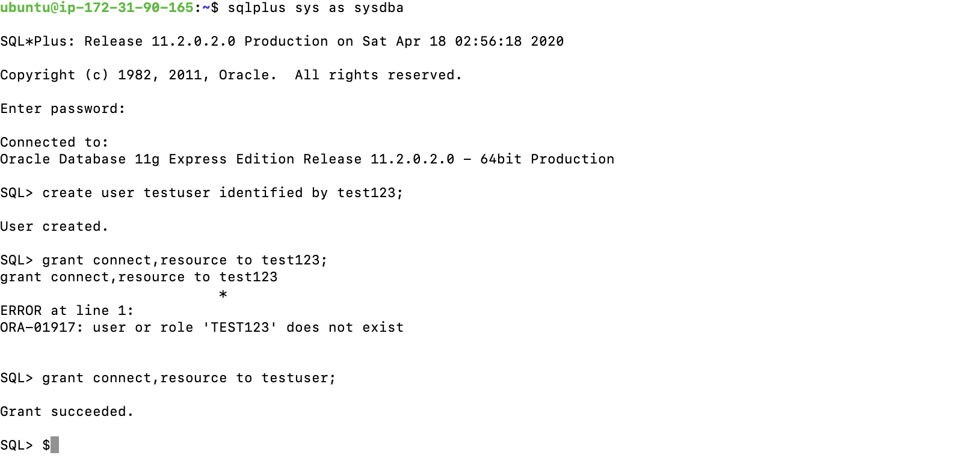

Tables of user : testuser



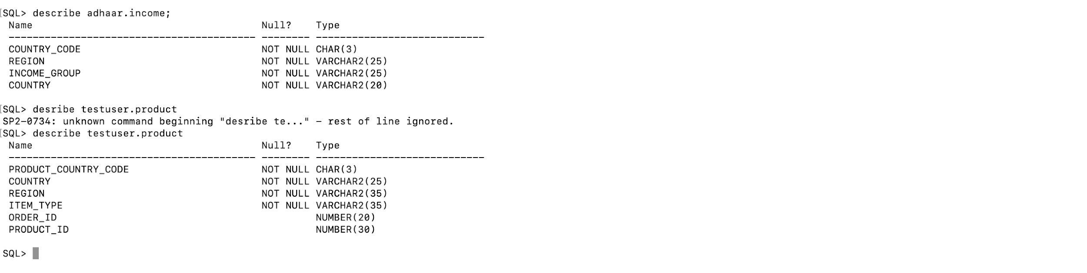

Now we are **granting security grants to both Income and Product tables**. For Income table it’s **user:adhaar** and for the product table its **user:testuser**

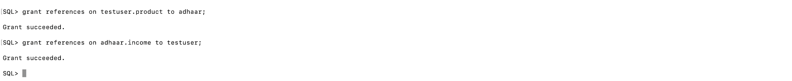

In this step we are **adding foreign key** to the product table which is the child table and income table is the parent in this case.

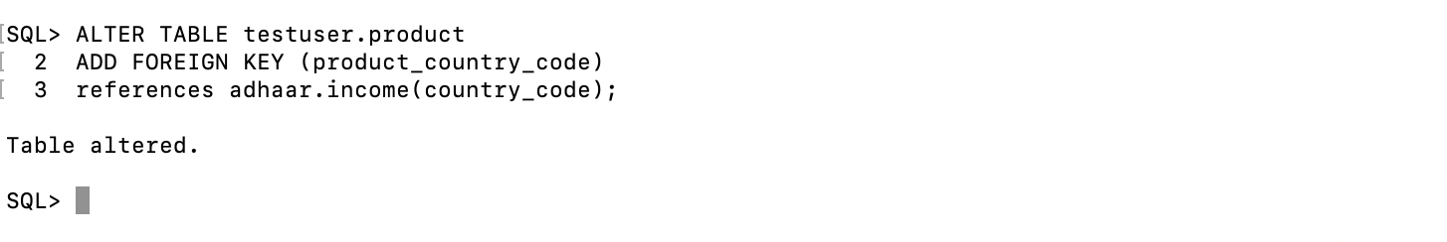

In this step we are performing **JOIN** on both the tables

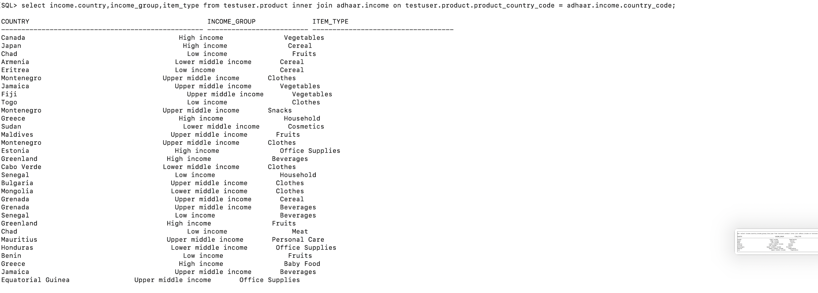

**Part 6: Visualization**

**Phase 1 Queries Answered**

**Query 1. How many countries lie under a high income group?**

Answer: There are **63 countries** which lie in the High Income Group all over the world. *We used the following query to answer this question.*



Additionally, the number of countries in the **Upper middle income group is 48**.

*We used the following query to answer this question.* 

The number of countries in the **Lower middle income group is 45**.

*We used the following query to answer this question.*



The number of countries in the **Low income group is 30**.

*We used the following query to answer this question.*

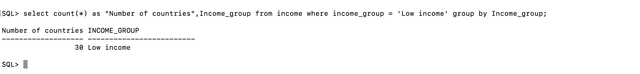

Bar and Pie graph for the above query are as follows:

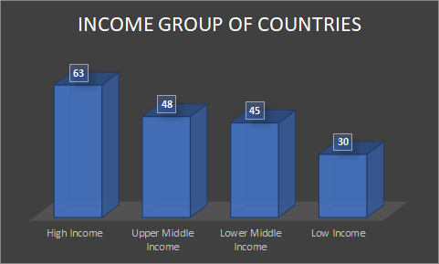

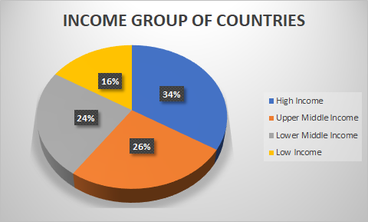

**Query 2. Name the top 5 richest states in the US.**

Answer - Below are the approximate Percentages of people living in the top 5 richest states in the US

**California - 31%**

**Texas - 25%**

**Florida - 18%**

**New York - 16%**

**Georgia - 10%**

*The above analysis is based on the value of Upper_level_people column in table*

*Income which represents the number of people living above the poverty line. We used the following query to answer this problem:*



*Bar graph and pie chart are as follows:*

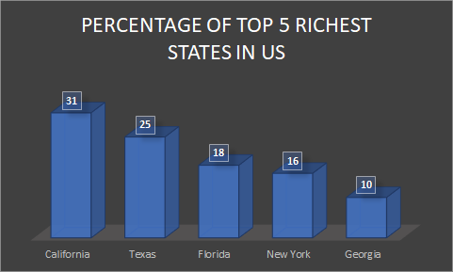

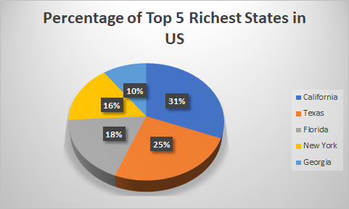

**Part 7: Layered Design with Views**

View Diagram shows the **3 datasets on the bottom row**. **View 1 and View 2 in the middle row** and **View 3 on the top row.**

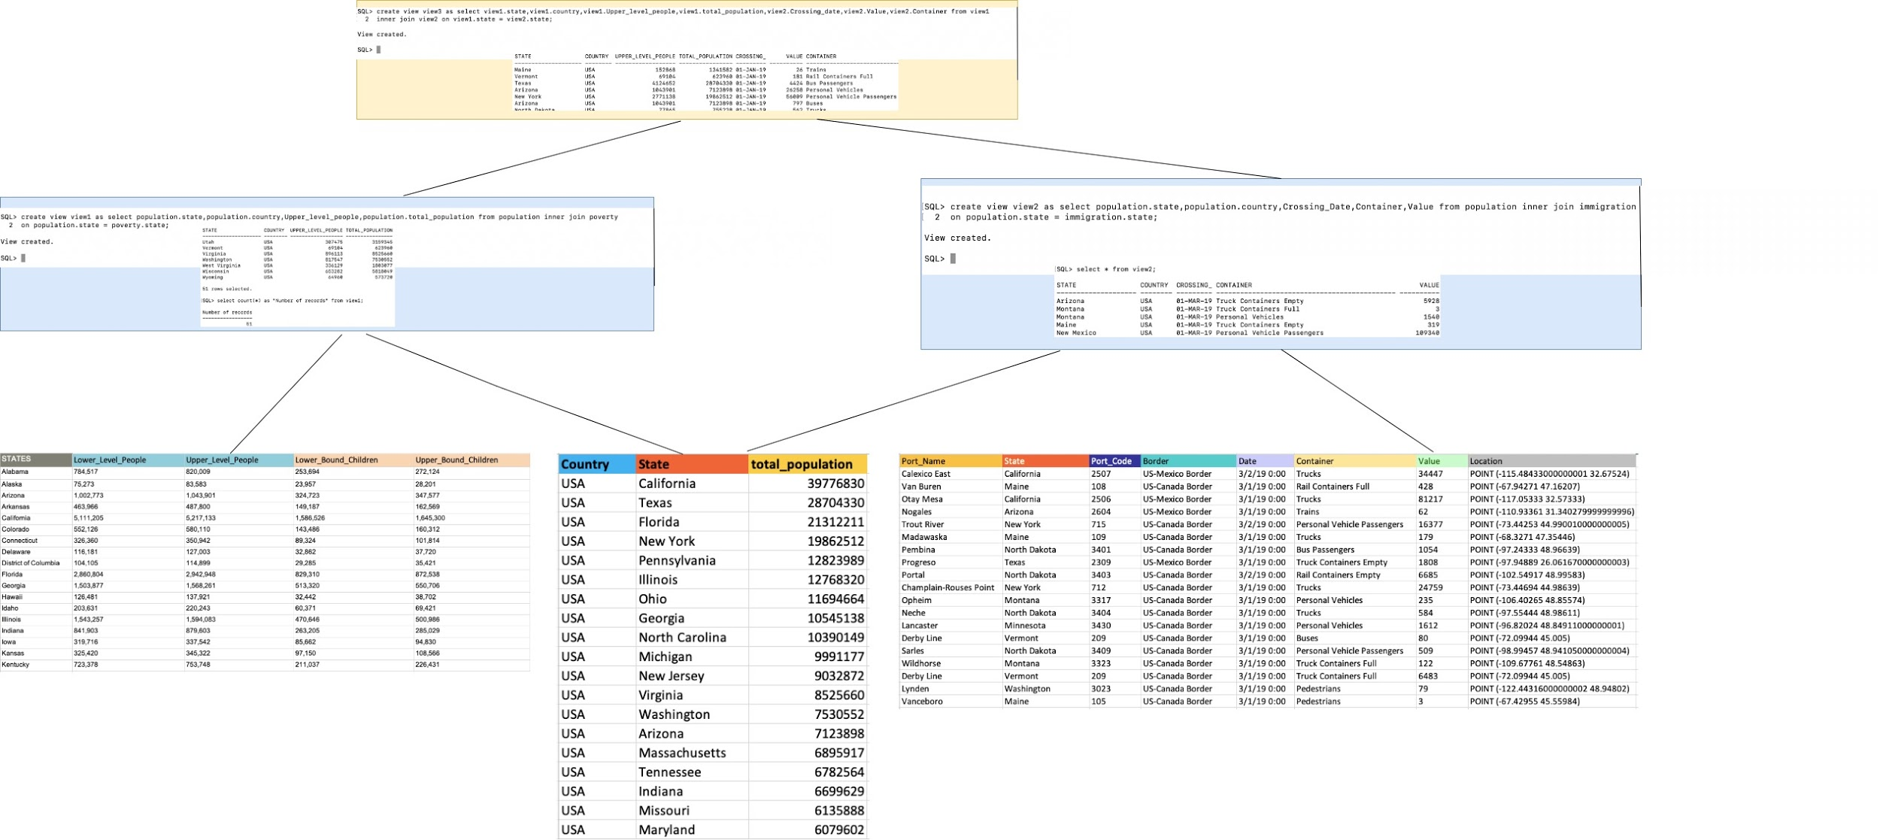

We have posted the bigger size screenshots and enlarged images from the above table down below in the following:

**View 1** is created by a **Join** of Table Population and Table Poverty

*View 1 screenshots of Query*



***View 1*** *screenshot of* ***Output***

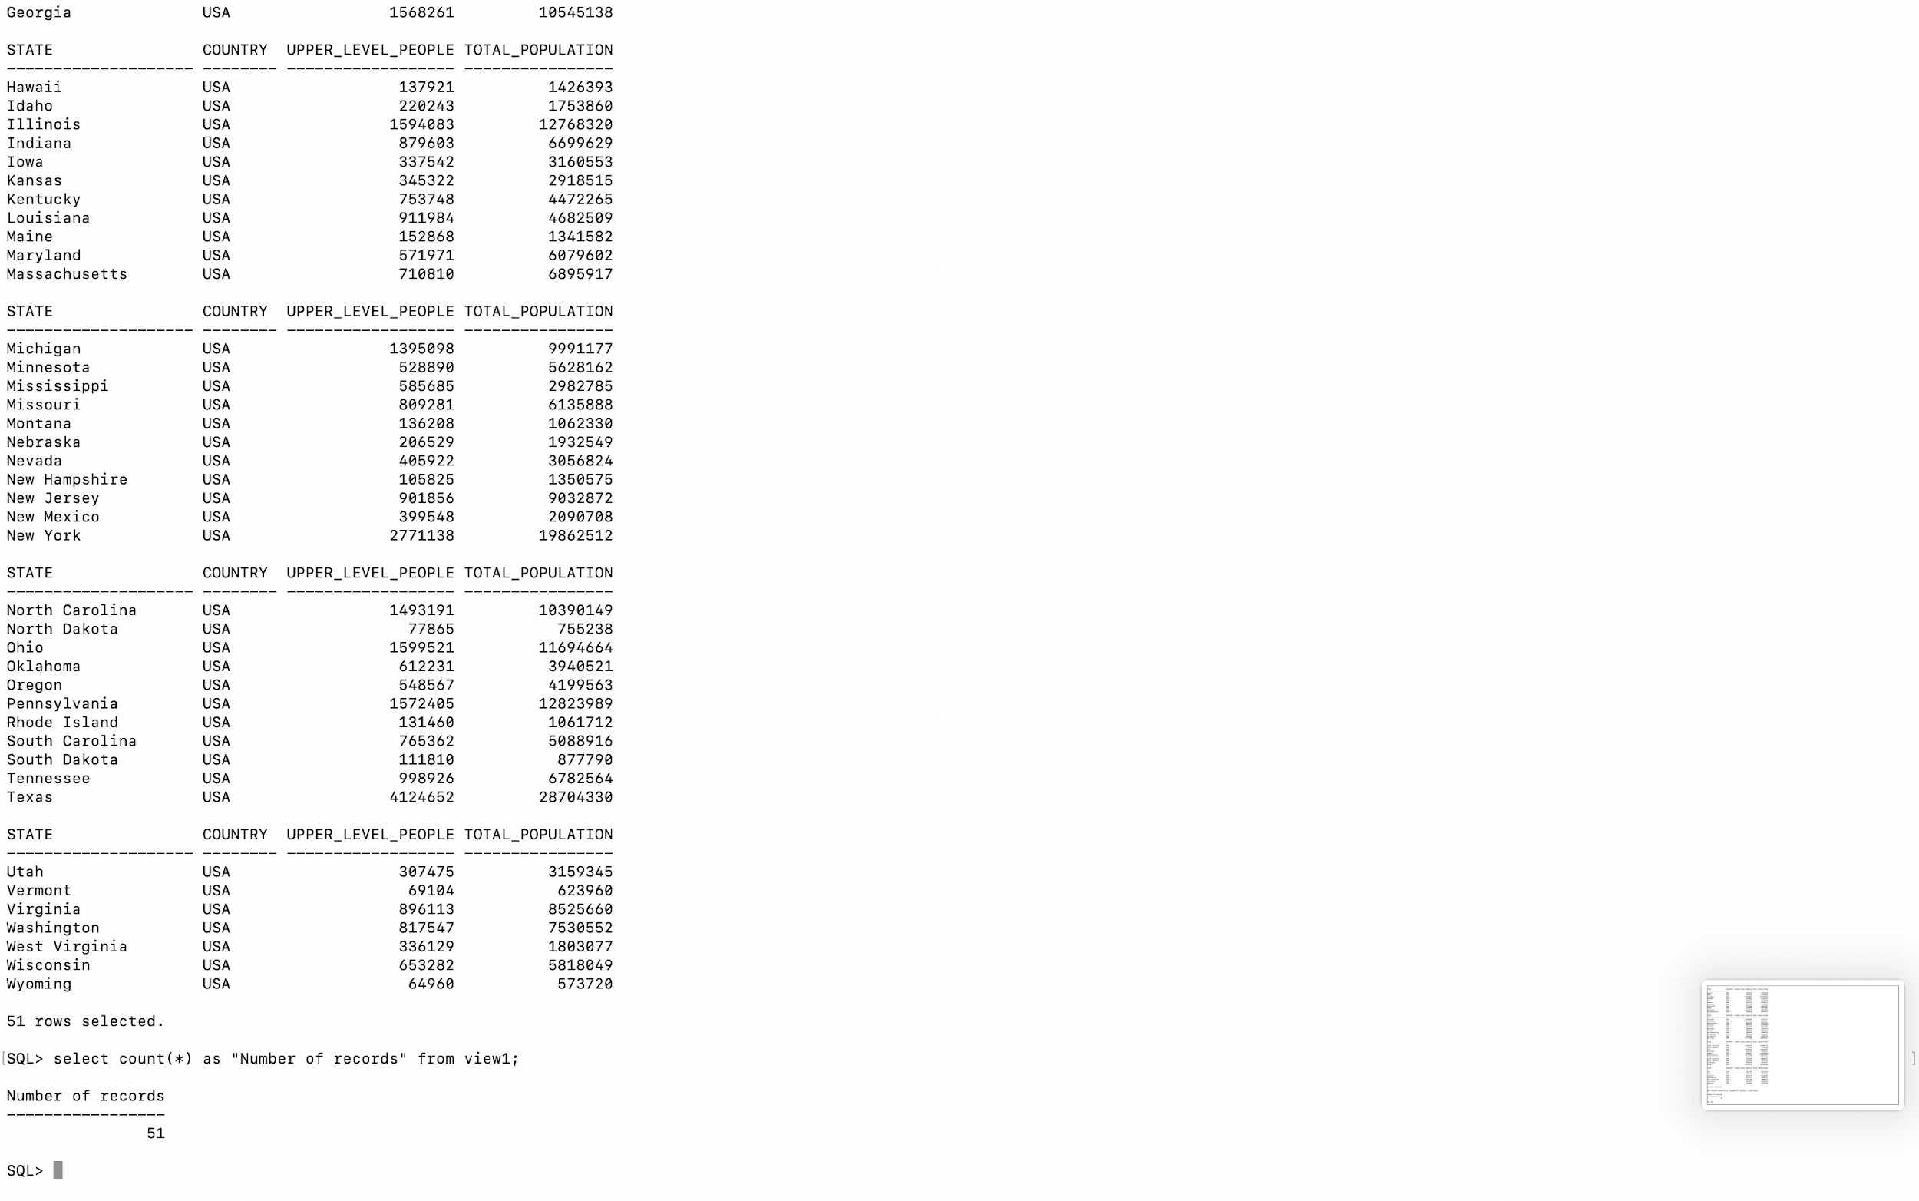

**View 2** is view created by a **Join** of Tables Population and Immigration

View 2 Screenshot of the Query:



***View 2*** *screenshot of Output*

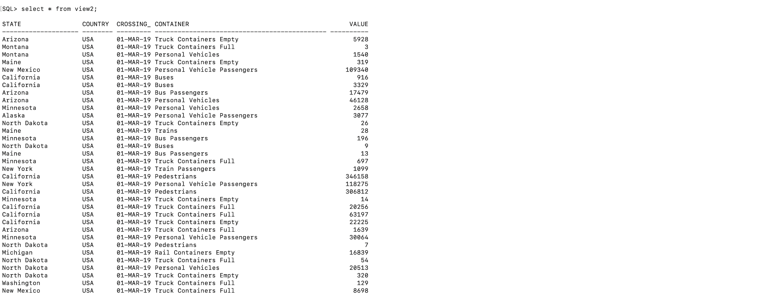

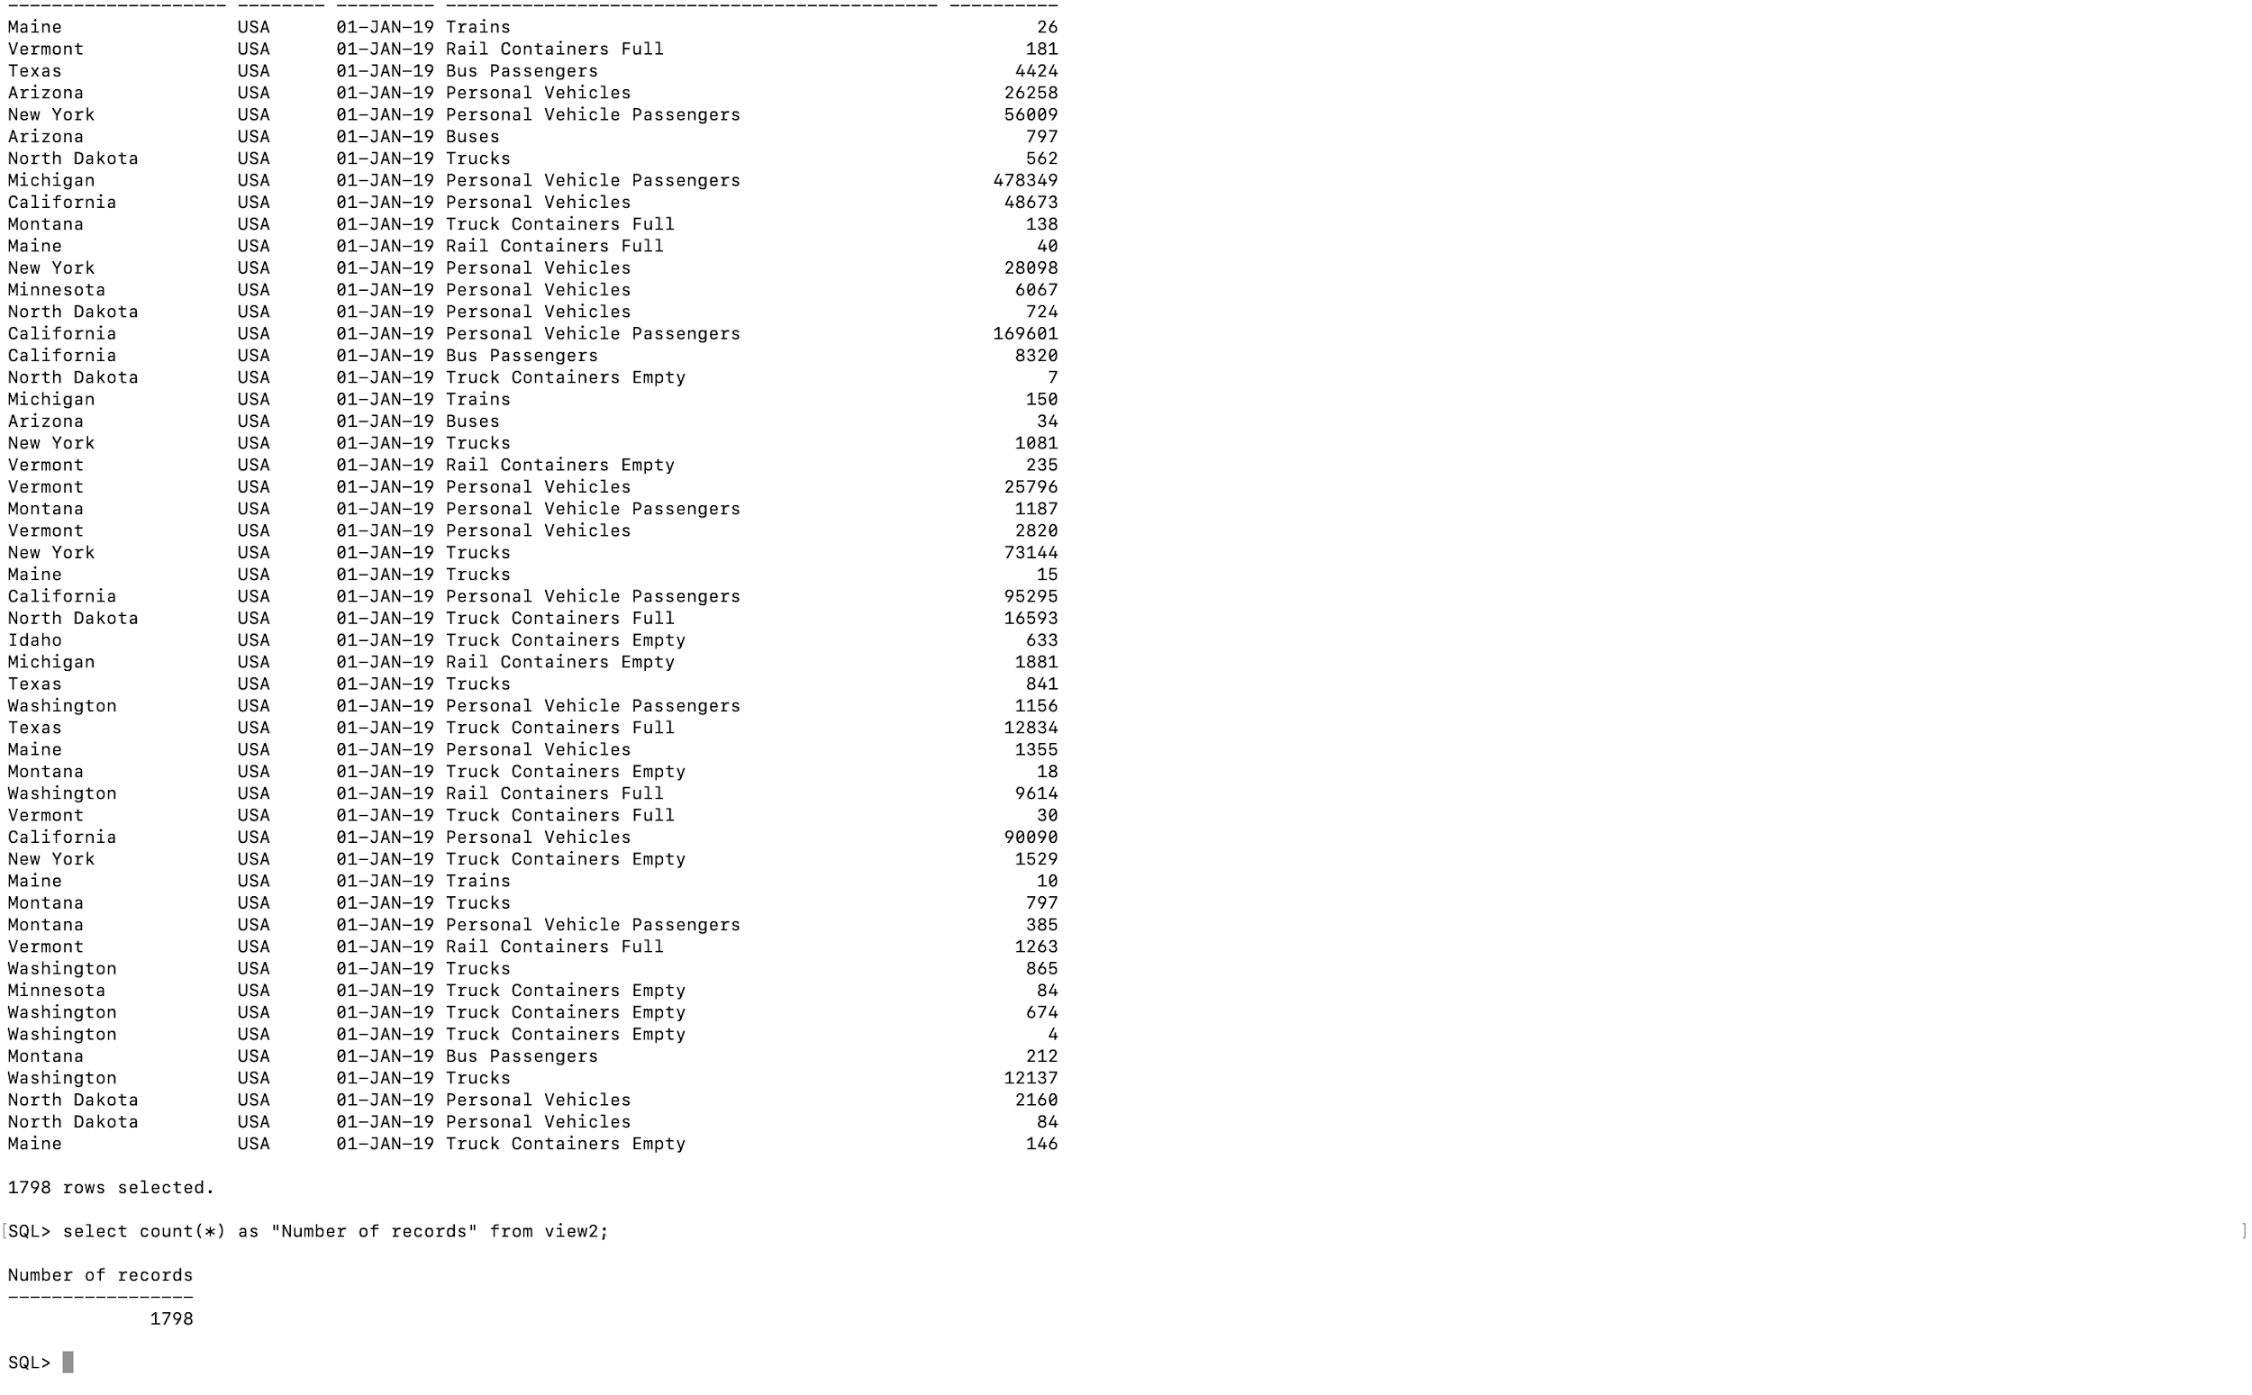

**View 3** is a join of View1 and View2

***View 3 Screenshot of Query***



*View 3 screenshot of Output*

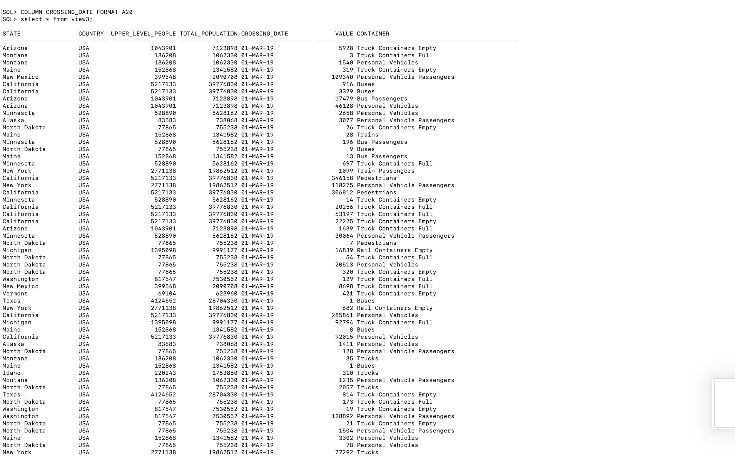

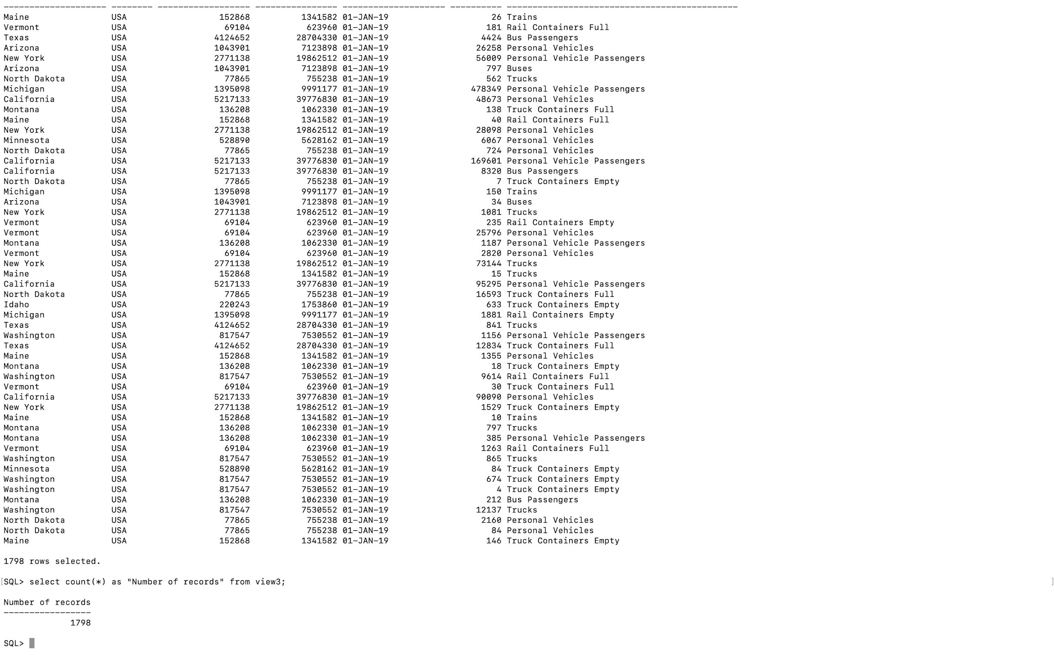

**Immigration Table** has a record with state as Maine and Value **146** and has **1798** records

*Screenshot of the output*



**View 3** is derived from Immigration table that has a record with state Maine and value **146** and **1798** records

Screenshot of the the output are as follows:



After deleting the record from table with state maine and value 146 from table immigration-



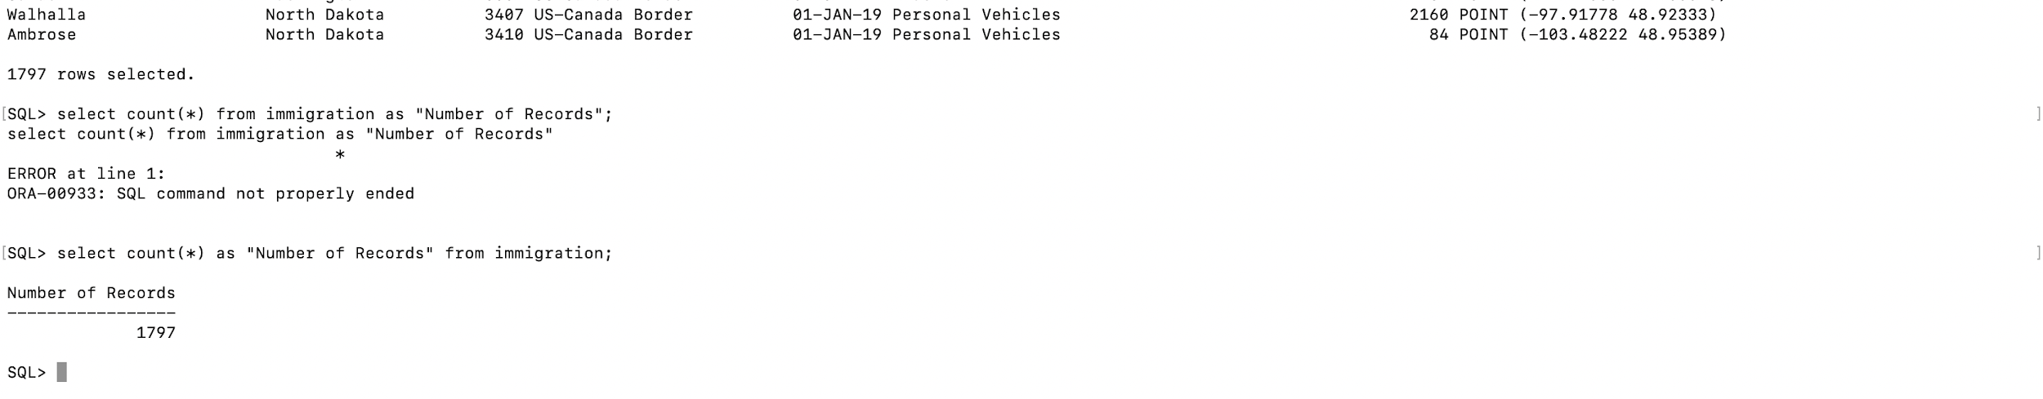

The record with state Maine and value **146** is also deleted from view3 and has **1797** records

Screenshots -

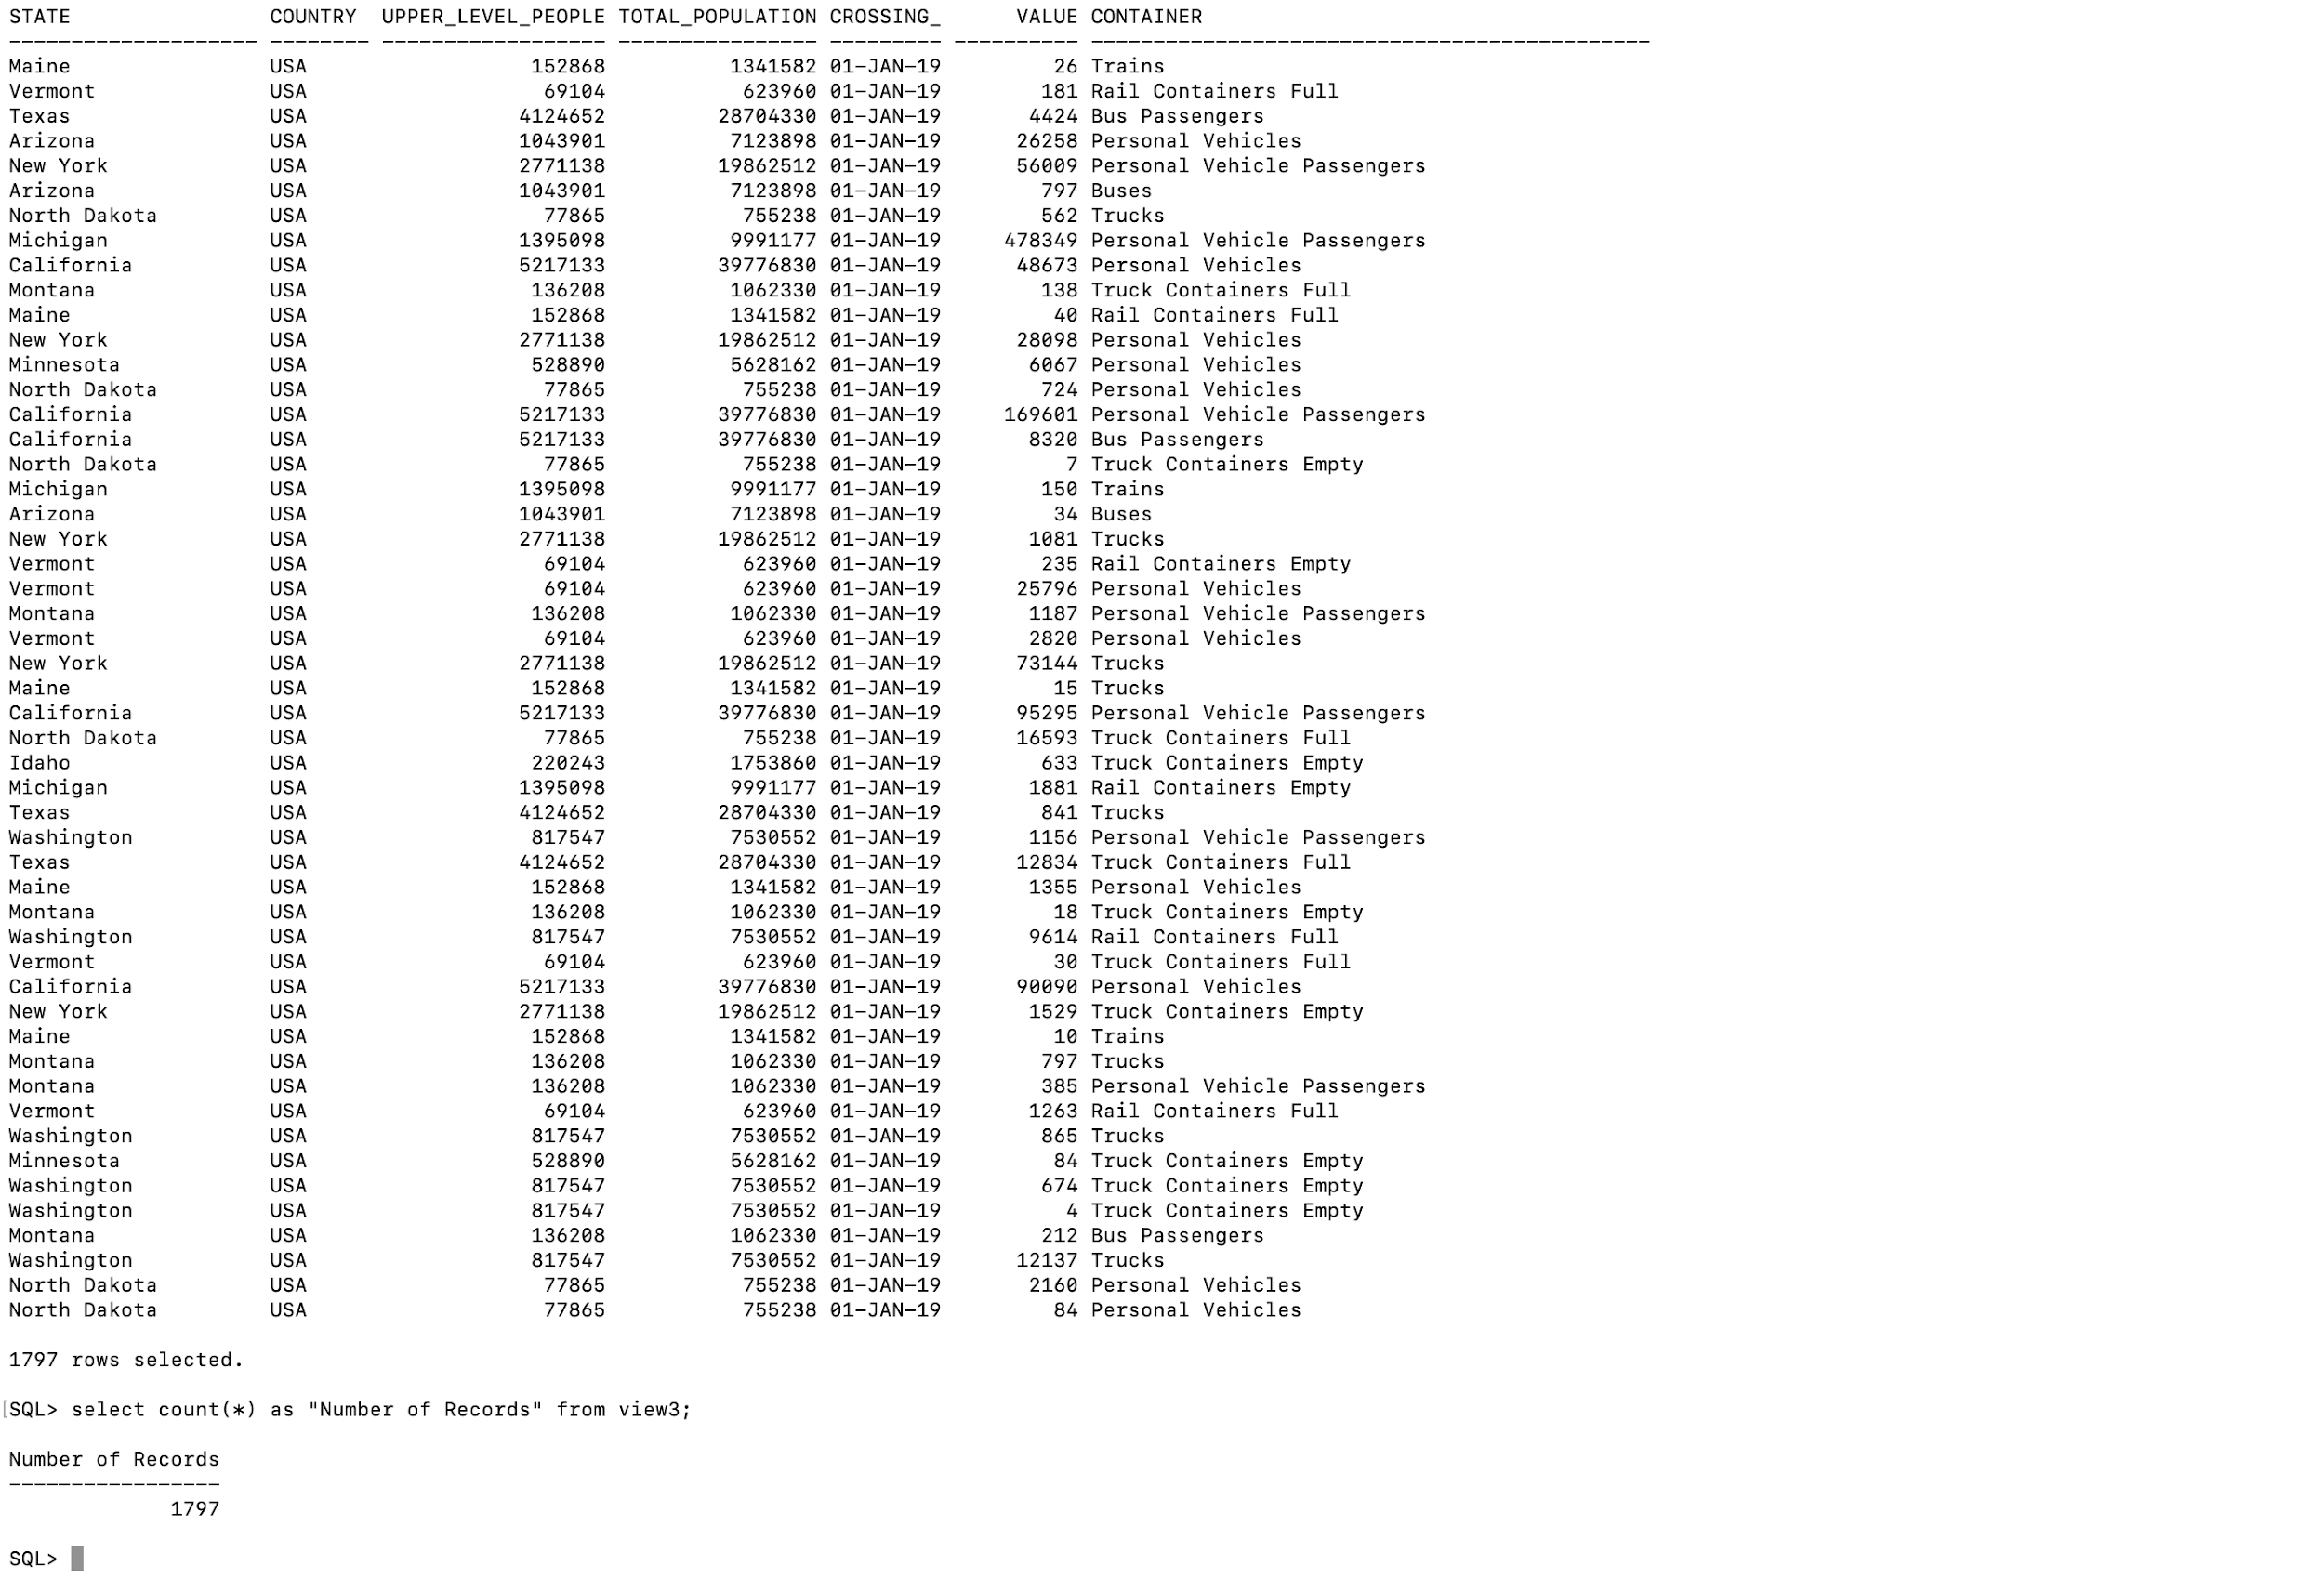

**Part 8: Pig on Hadoop**

This is previously done on Dataset, Poverty.csv and State_Population.csv

**Uploading Poverty.csv and State.csv**

hadoop fs -put Poverty.csv P.txt

hadoop fs -put State.csv S.txt

Pig

Grunt>ls

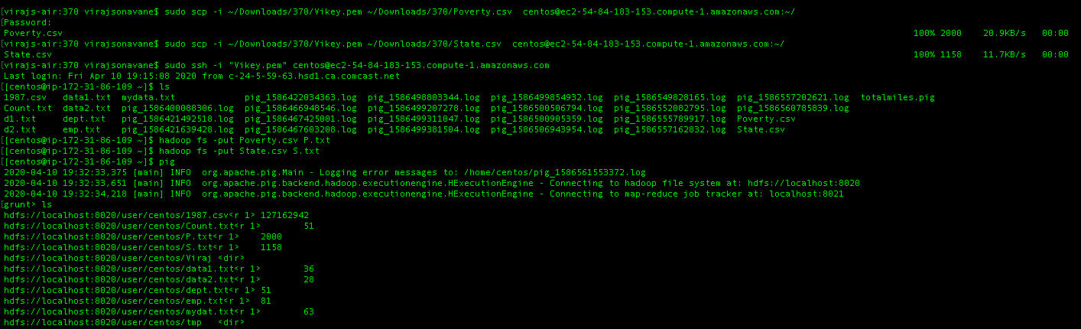

**Overview of Poverty table**

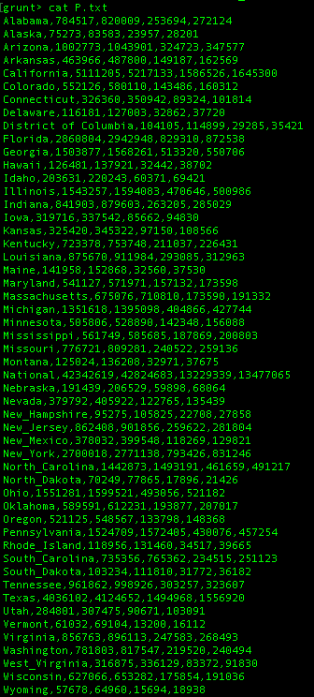

**Overview of State table**

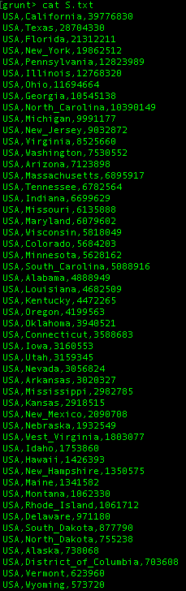

**Flow Diagram:**

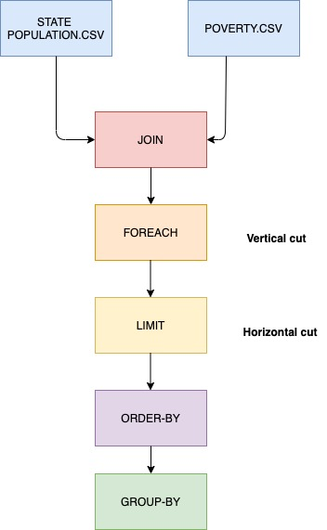

**Loading Poverty table in to A;**

A = Load ‘P.txt’ using pigstorage(‘,’) as (State:Chararray,LowerPeople:int, Upperpeople:int, LowerChildren:int, UpperChildren:int)

Dump A;

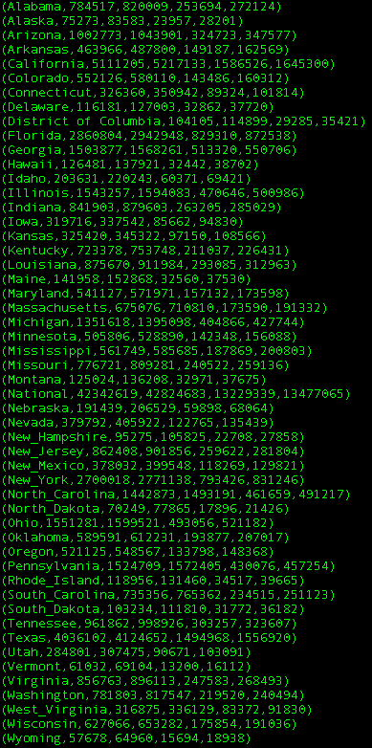

**Loading State table in to B;**

B = Load ‘S.txt’ using pigstorage(‘,’) as (Country:Chararray,State:Chararray,Population:int)

Dump B;



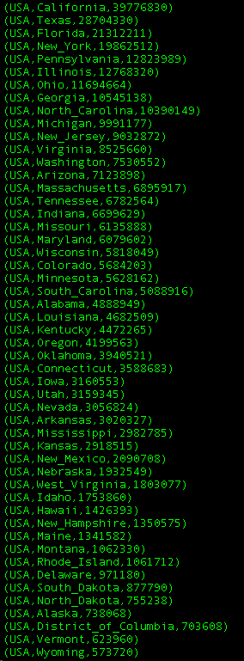

**Preview of Poverty Table**

Illustrate A;



**Preview of State Table**

Illustrate B;

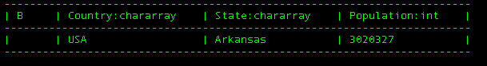

**Applying Left Outer Join on Both the table using State**

J = JOIN A by State left outer, B by state;



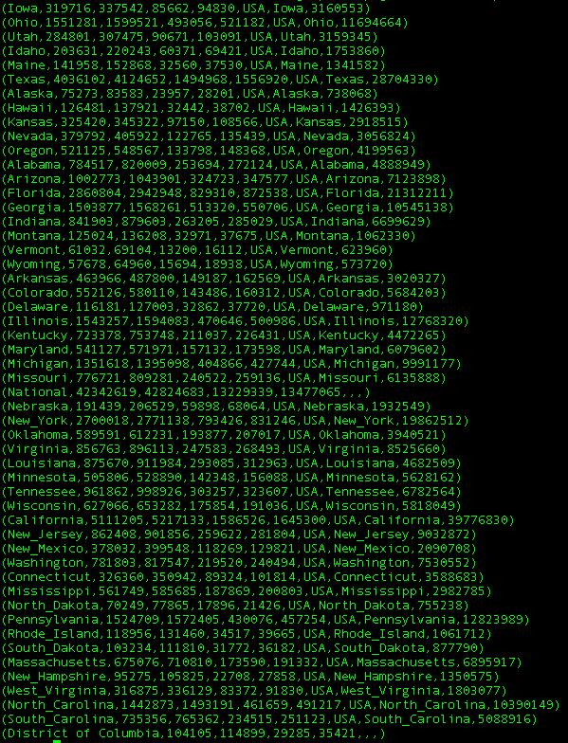

**Applying Foreach on Join using State, Population, LowerChildren.**

G = Foreach J generate State,Population,LowerChildren;

Describe G;

Dump G;

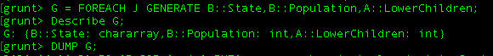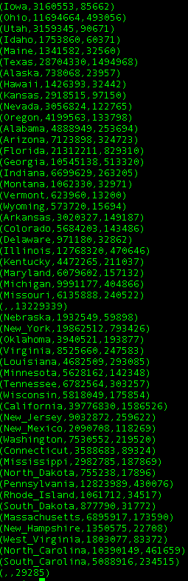

**Applying Limit on G of 50**

L = Limit G 50;

DUMP L;

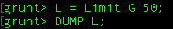

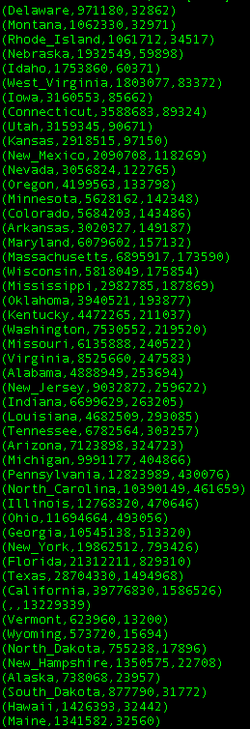

**Applying Order by on Obtained Limited L**

O = Order L by State ASC;

Describe O;

Dump O;

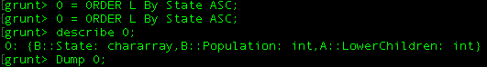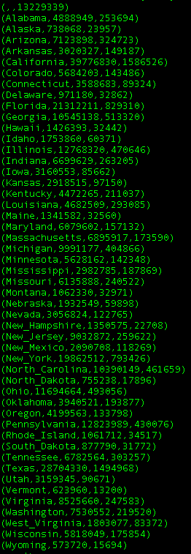

**Applying Group By State**

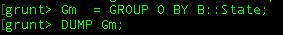

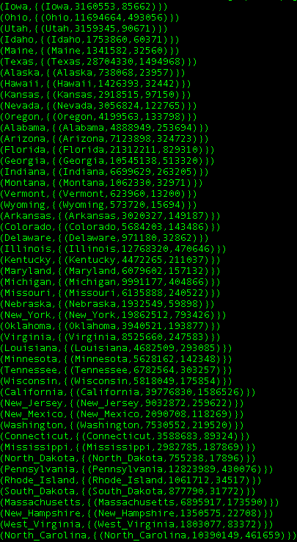

**Applying Group By LowerChildren**

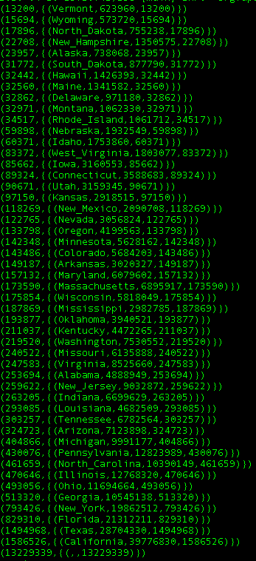

**Flow Diagram:**

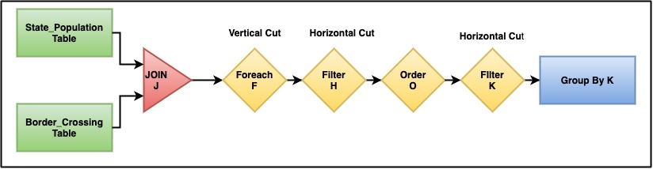

Now adding, new Dataset BorderCrossing Cross.csv,

**Uploading Border_cross.csv and State.csv**

hadoop fs -put Cross.csv Cross.txt



**Overview of table Cross.txt**

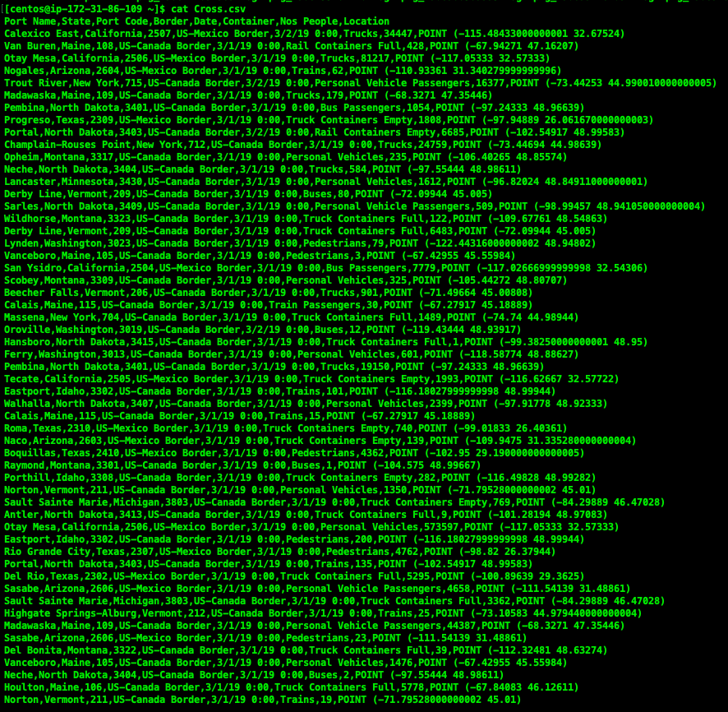

**Continuing output**

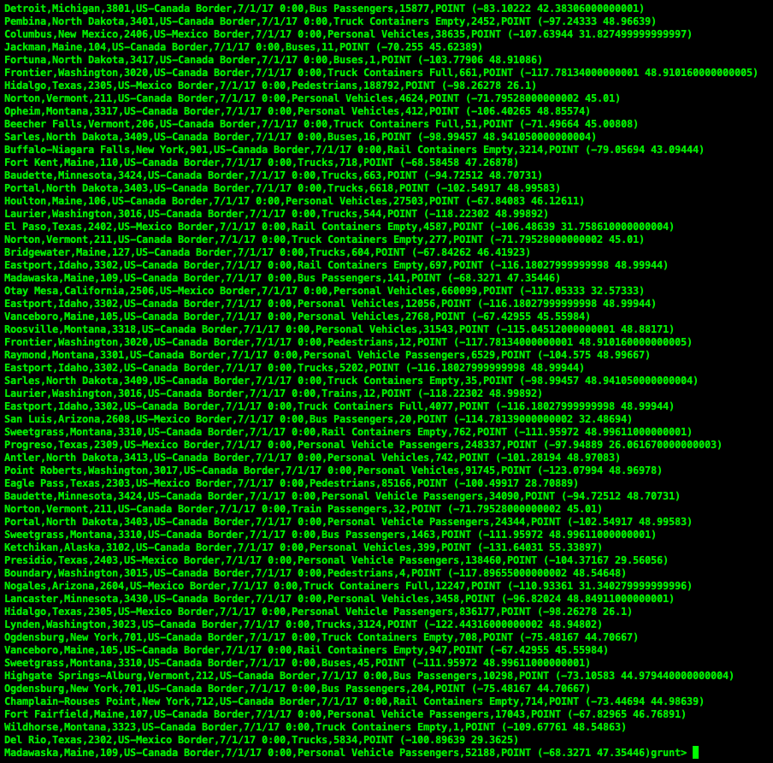

**End**

**Here we are loading State table in to B;**

**B = Load ‘S.txt’ using pigstorage(‘,’) as (Country:Chararray,State:Chararray,Population:int)**

**Dump B;**



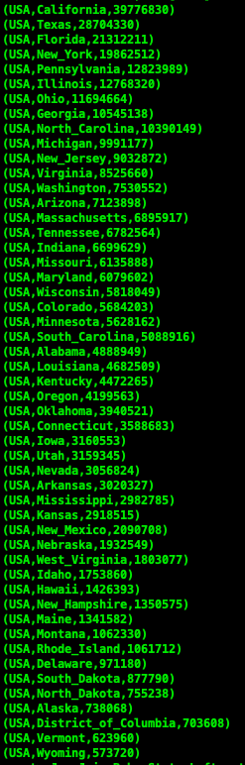

**End output**

**Here we are loading State table in to A;**

**A = Load ‘Cross.txt’ using pigstorage(‘,’) as (Country:Chararray,State:Chararray,Population:int)**

**Dump B;**

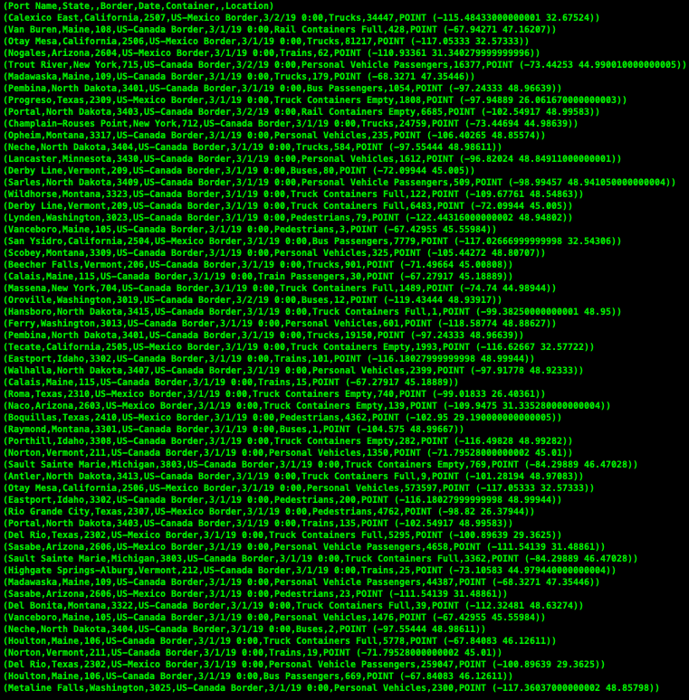

.

.

.

.

.

.

.

.

**continue**

**.**

**.**

**continue**

.

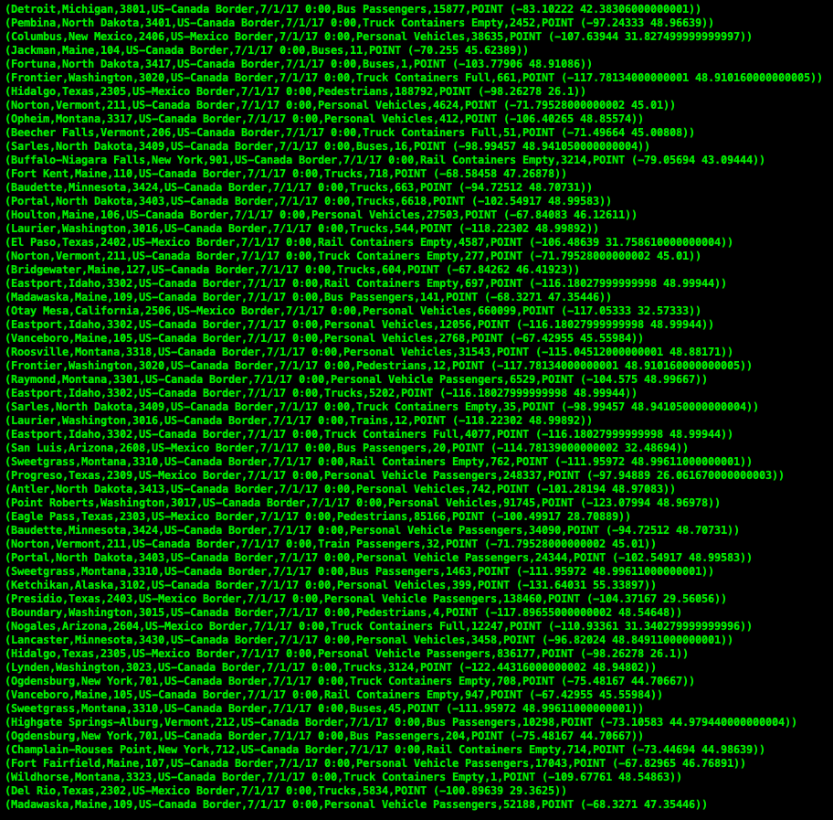

**End output**

**Preview of State Table is as shown below with one data and its attributes.**

Illustrate B;



**Preview of Boardercross Table is as shown below with one data and its attributes**

Illustrate A;



Here are applying **Left Outer Join** on Both the table using **State,** to get output **as** below

J = JOIN A by State left outer, B by state;

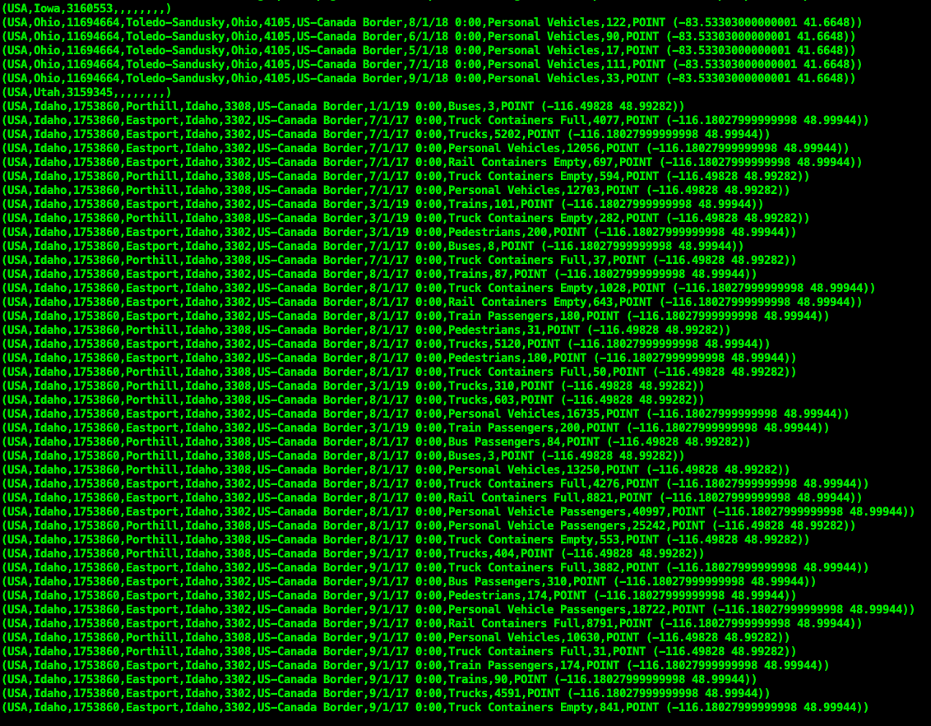

.

.

.

.

.

.

**continue**

.

.

.

.

.

.

.

.

.

.

.

.

**Continue output**



**End output**

**Applying Foreach on Join using State, Population, Port_name, Date, container,Nos.**

F = Foreach J generate A::State,A::Population,B::Port_namr, Date, B::container, B::Nos_people;

Describe F;

Dump F;



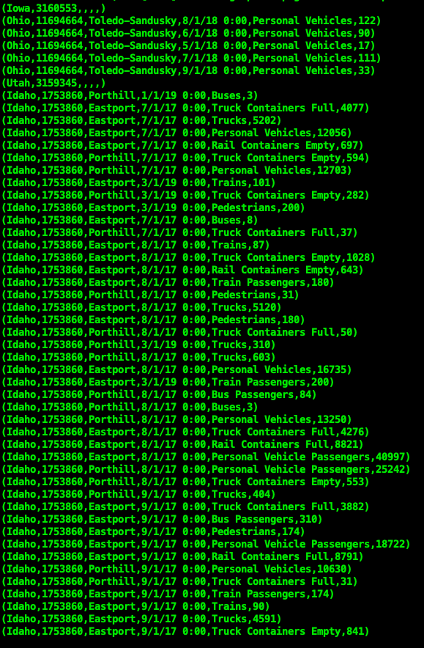

.

.

**Continue**

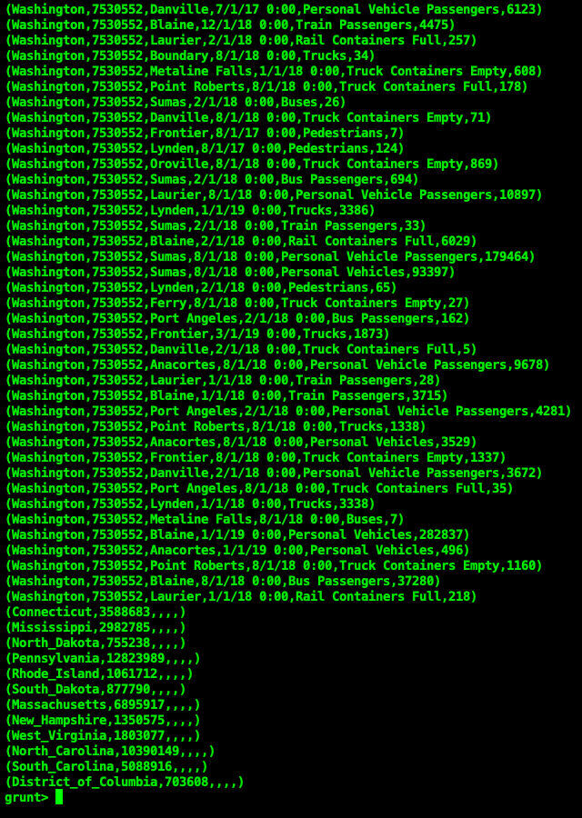

**End output**

**Applying Filter F by container.**

H = Filter F by container == ‘Buses’;

Describe H;

Dump H;



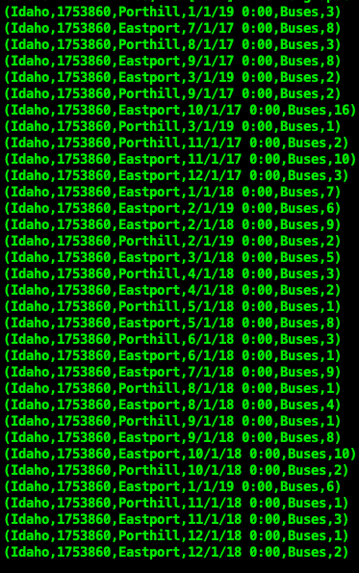

.

.

.

.

.

.

.

.

.

.

.

.

continue

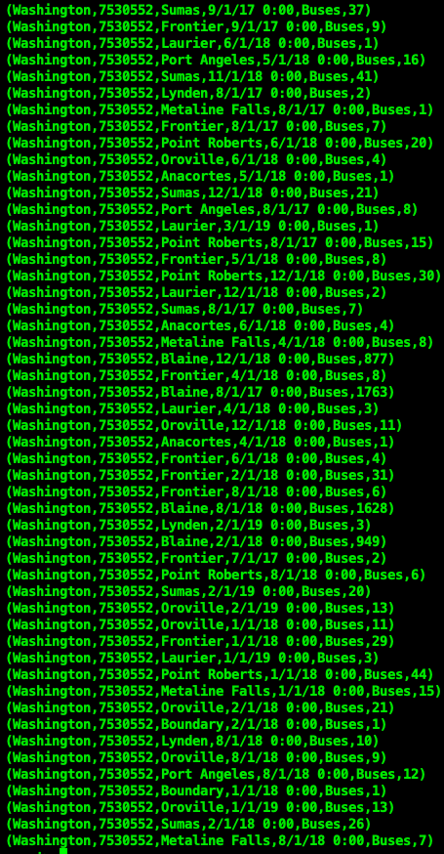

End output

**Applying Order by on H by State in ascending order**

O = Order H by State ASC;

Describe O;

Dump O;

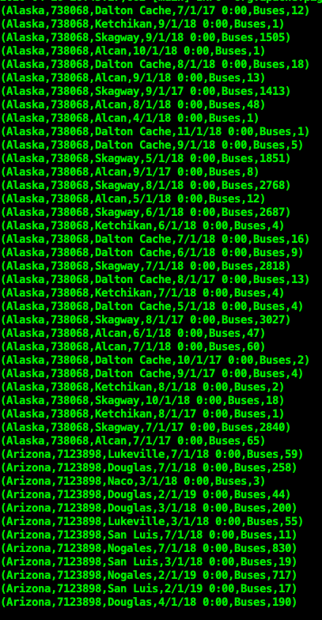

.

.

**Continue**

.

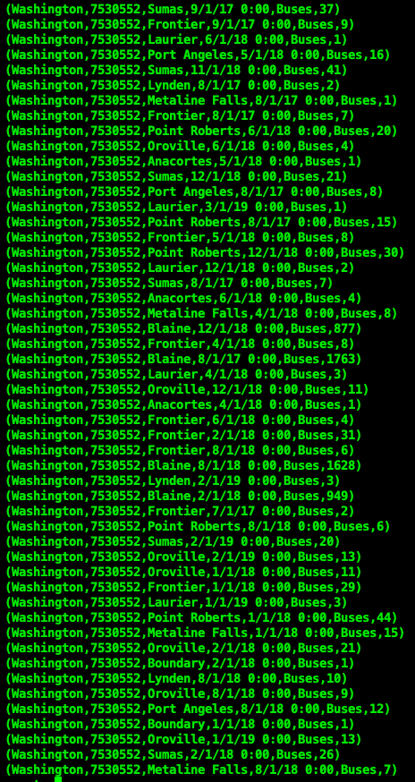

**end output**

**Applying Filter again on O By State California**

k = Filter O by State == ‘California’;

Describe k;

Dump k;



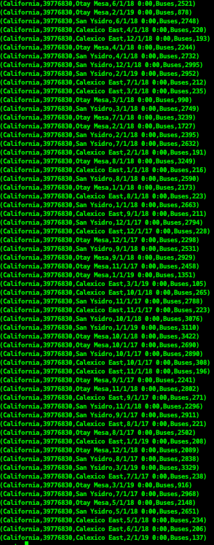

**Applying Group By on k By Date**

Gm = Group k by Date;

Describe Gm;

Dump Gm;

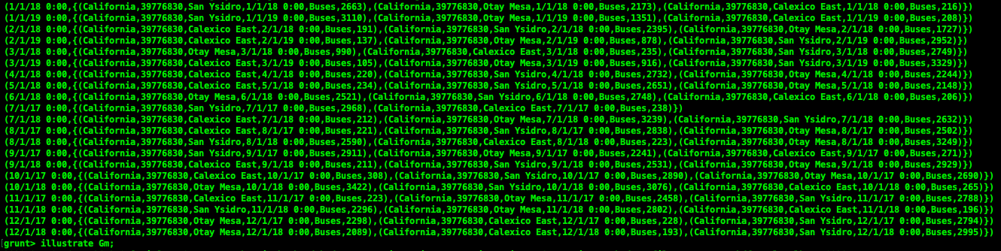

**Part 9: Store Procedure**

Firstly creating table named :**customer** with Attributes as ID, Name, AccountNo and Branch

Command:

**Command: SQL>Select*from customer;**

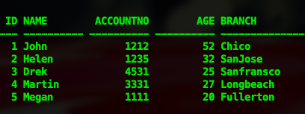

**Command: SQL>Describe customer;**

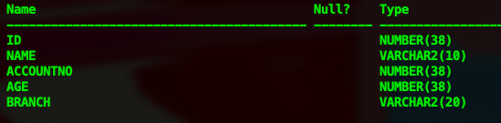

* Setting v_id = ID, v_name = Name, v_acc = AccountNo, v_age = v_age and v_branch = Branch to match coding parameters with that of table attributes.
* Modifying given code, to get **Branch** of Customer with **ID = 1**.
* Using **While** **loop** to get **Age** of all the Customer and using **If condition** to get **Name** of the Customer whose AccountNo is greater than 1000
* **I had a lot of trouble with the procedure shows compiler error** which was due to wrong syntax being used**.**

**Main Code:**

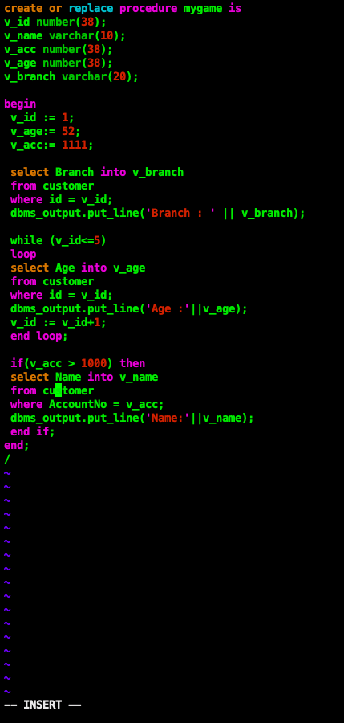

**Code output:**

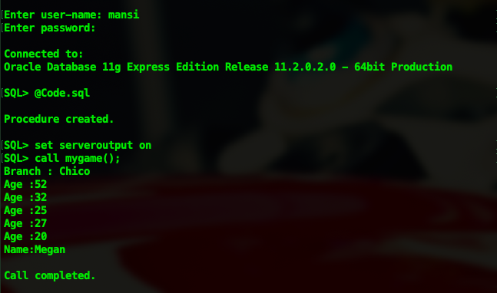

**Part 10: PL/SQL Cursor**

**Implicit Cursor example 1**:

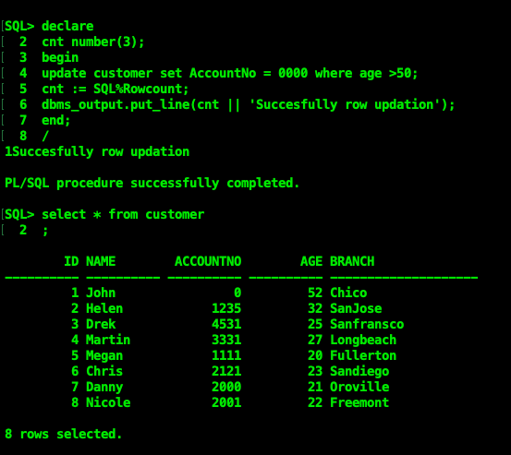

* In this Code we use implicit cursor **SQL%Rowcount**  to get count of the rows that are inserted.
* The AccountNo of the customer is set to zero when Age of the customer is greater than 50.
* And cnt is used to get affected rows using **SQL%Rowcount.**
* Hence in the output John AccountNo now equals zero.

**Implicit Cursor example 2 :**

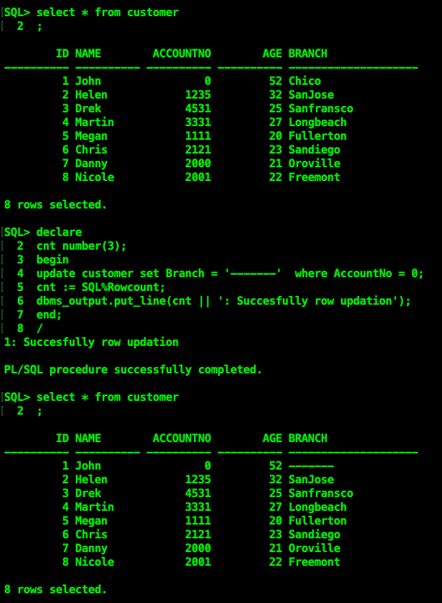

* In this Code also we use implicit cursor **SQL%Rowcount**  to get the count of the rows that are inserted.
* The Branch of the customer is set to ‘----’ when AccountNo of the customer is zero or NULL. And cnt is used to get affected rows using **SQL%Rowcount.**
* Hence, in output John Branch now equals to Null or ‘------’.

**Explicit Cursor 1:**

The Customer table on which we use the explicit cursor is as follows,

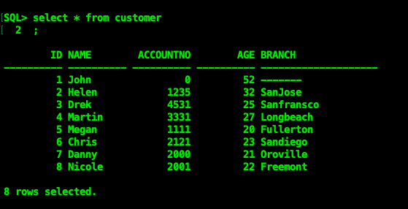

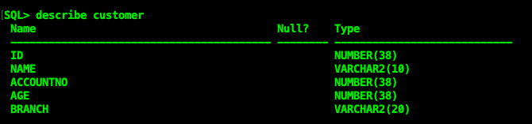

* In this code we use an explicit cursor named **tbl_cursor%Rowcount** and **tbl_cursor% Notfound**.
* We set v_id = customer.ID, v_name = customer.Name, v_branch = customer.Branch to match table attributes with these variables.
* We are using one **tbl_ cursor** to fetch data from the customer table like ID,name and Branch of customers.
* And the other tbl_cursor to run the loop till count greater than 8. Hence, from that loop we obtain output with ID, Name and Branch of all the customers.

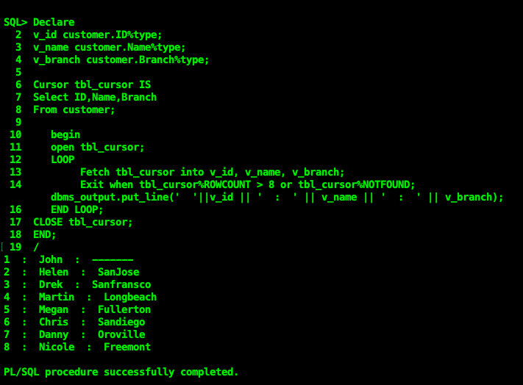

**Part 11. PL/SQL Trigger**

The datatable used for trigger is customer describe as follow,

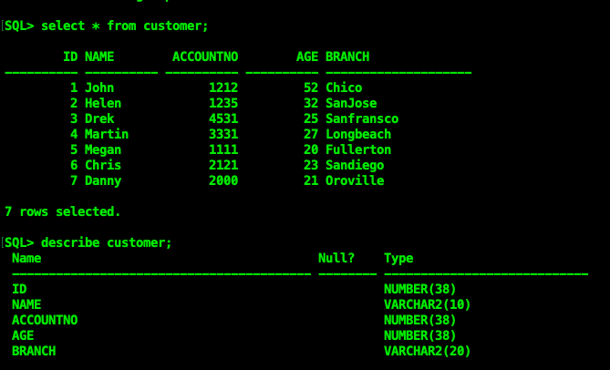

**Trigger1**:

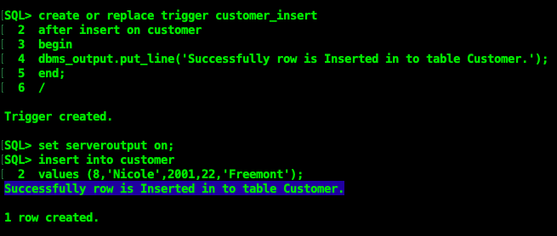

* Here we use trigger name **customer_trigger**.
* The trigger get activated when a row is inserted into the table
* The trigger displays 'Successfully row is inserted into table customer,’
* The output of the table show newly inserted row ID = 8.

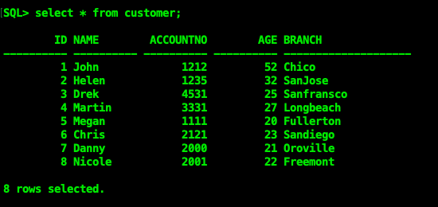

**Part 12: Live User Interface**

User Interface:

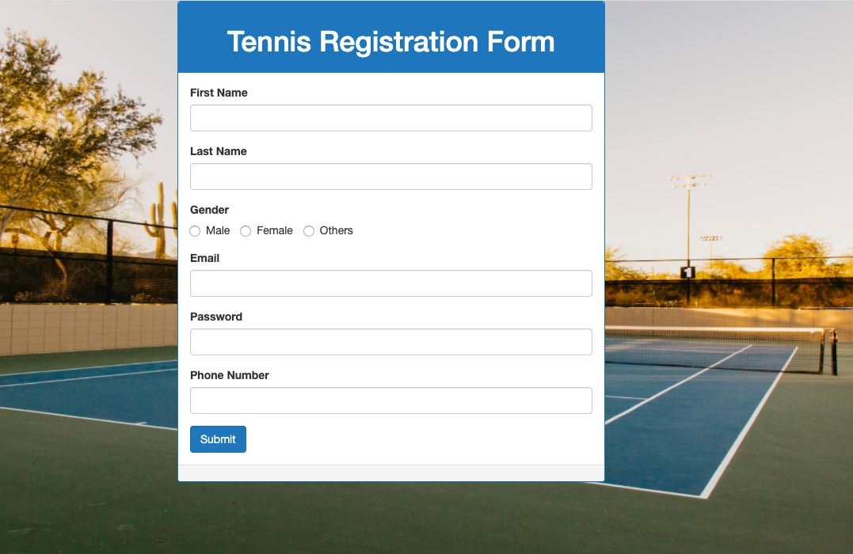

*None of our group members knew how to use HTML but rather than skipping these parts we decided to give it a try and it turned out that the user interface part was the most fun out of all other parts. We used Xampp and overall we learned a little about HyperText Markup Language.*

*HTML code for the above user interface:*

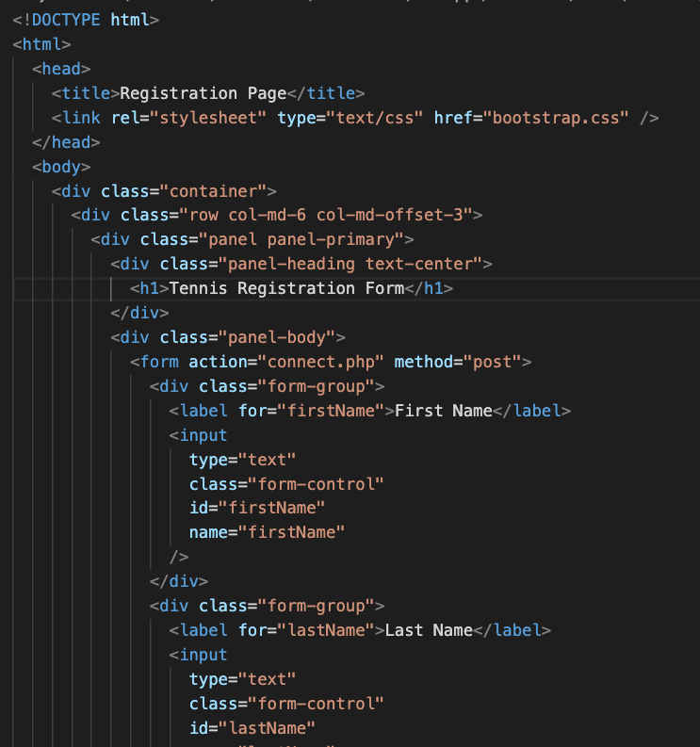

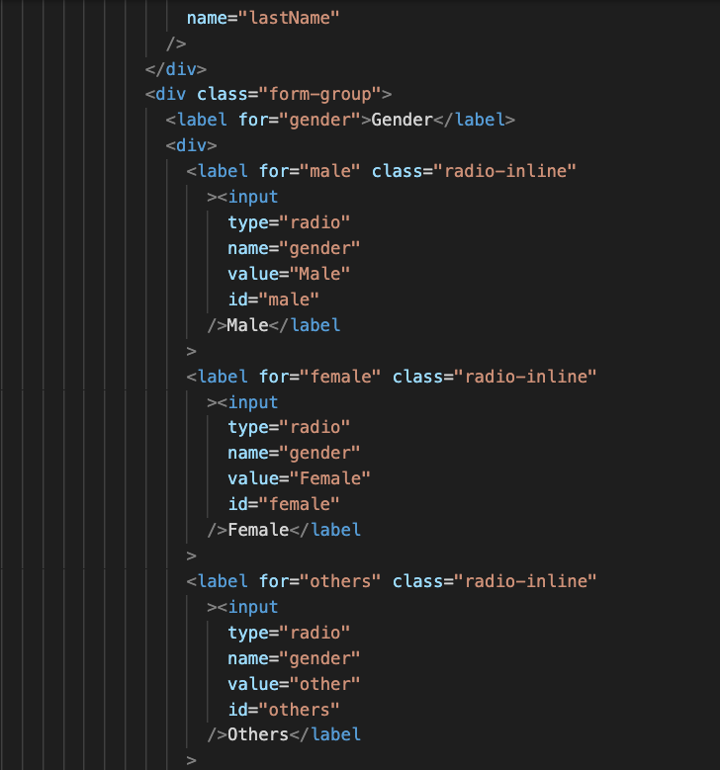

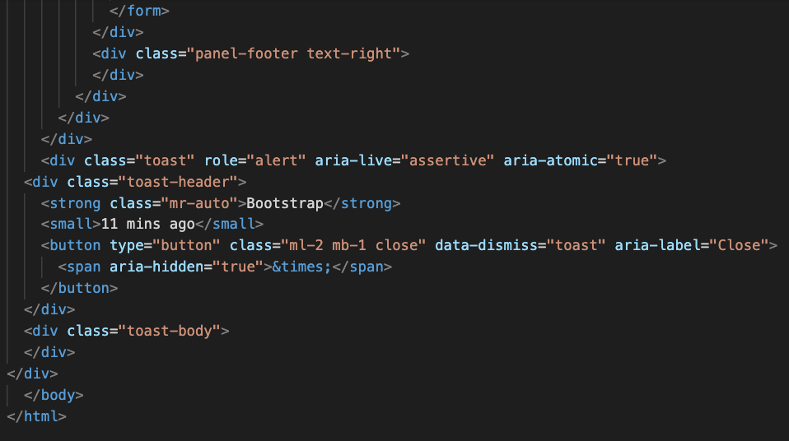

**PHP CODE FOR THE ABOVE USER INTERFACE**

Connect.php

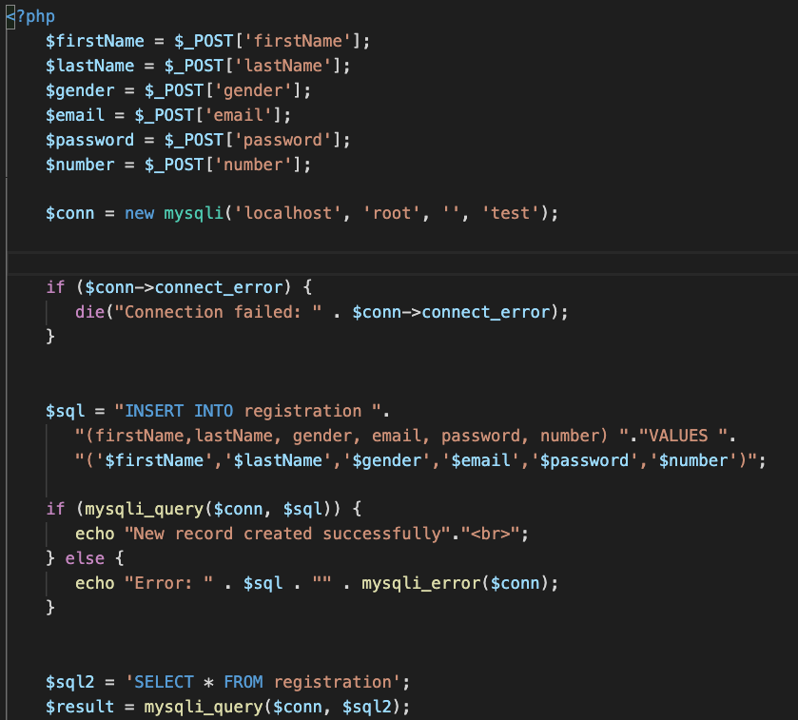

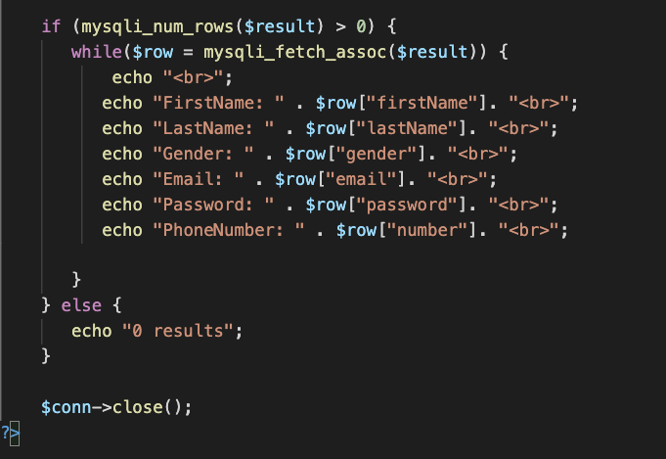

**MYSQL**

The reflected database output for when Submit button is being pressed each time:

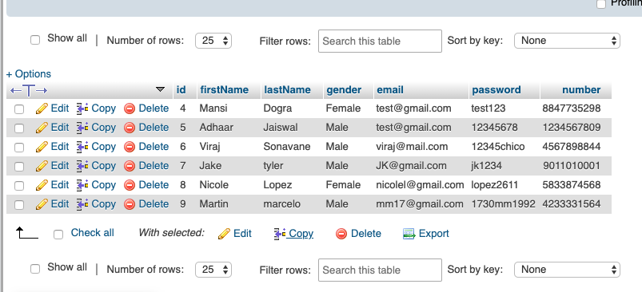

**Structure of database:**

Describe table test:

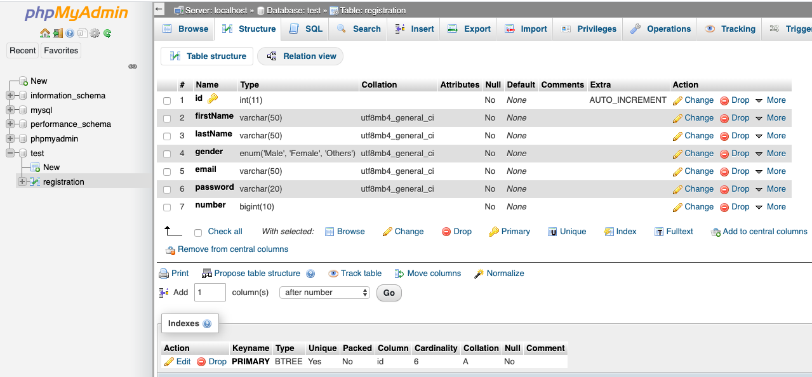

*OUTPUT AFTER FILLING IN THE USER INTERFACE FORM AND USING BUTTONS*

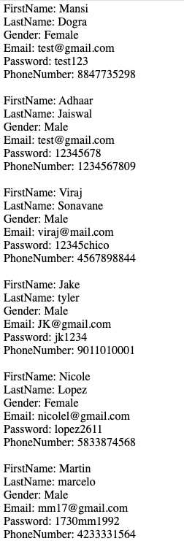

**Part 13. Combine Tools**

We made a connection to Oracle Aws Instance using Python. At first we connected python to oracle using cx_Oracle module. We have also shown the columns country_code and Country from the income table in the output.

*None of our group members knew this either and we had spent the longest time on zoom meetings to figure out how to make connections as it timed out on us more than 20 times at least. Finally we got it after 2 days of struggle, we are very glad that we attempted all 13 parts of this project.*

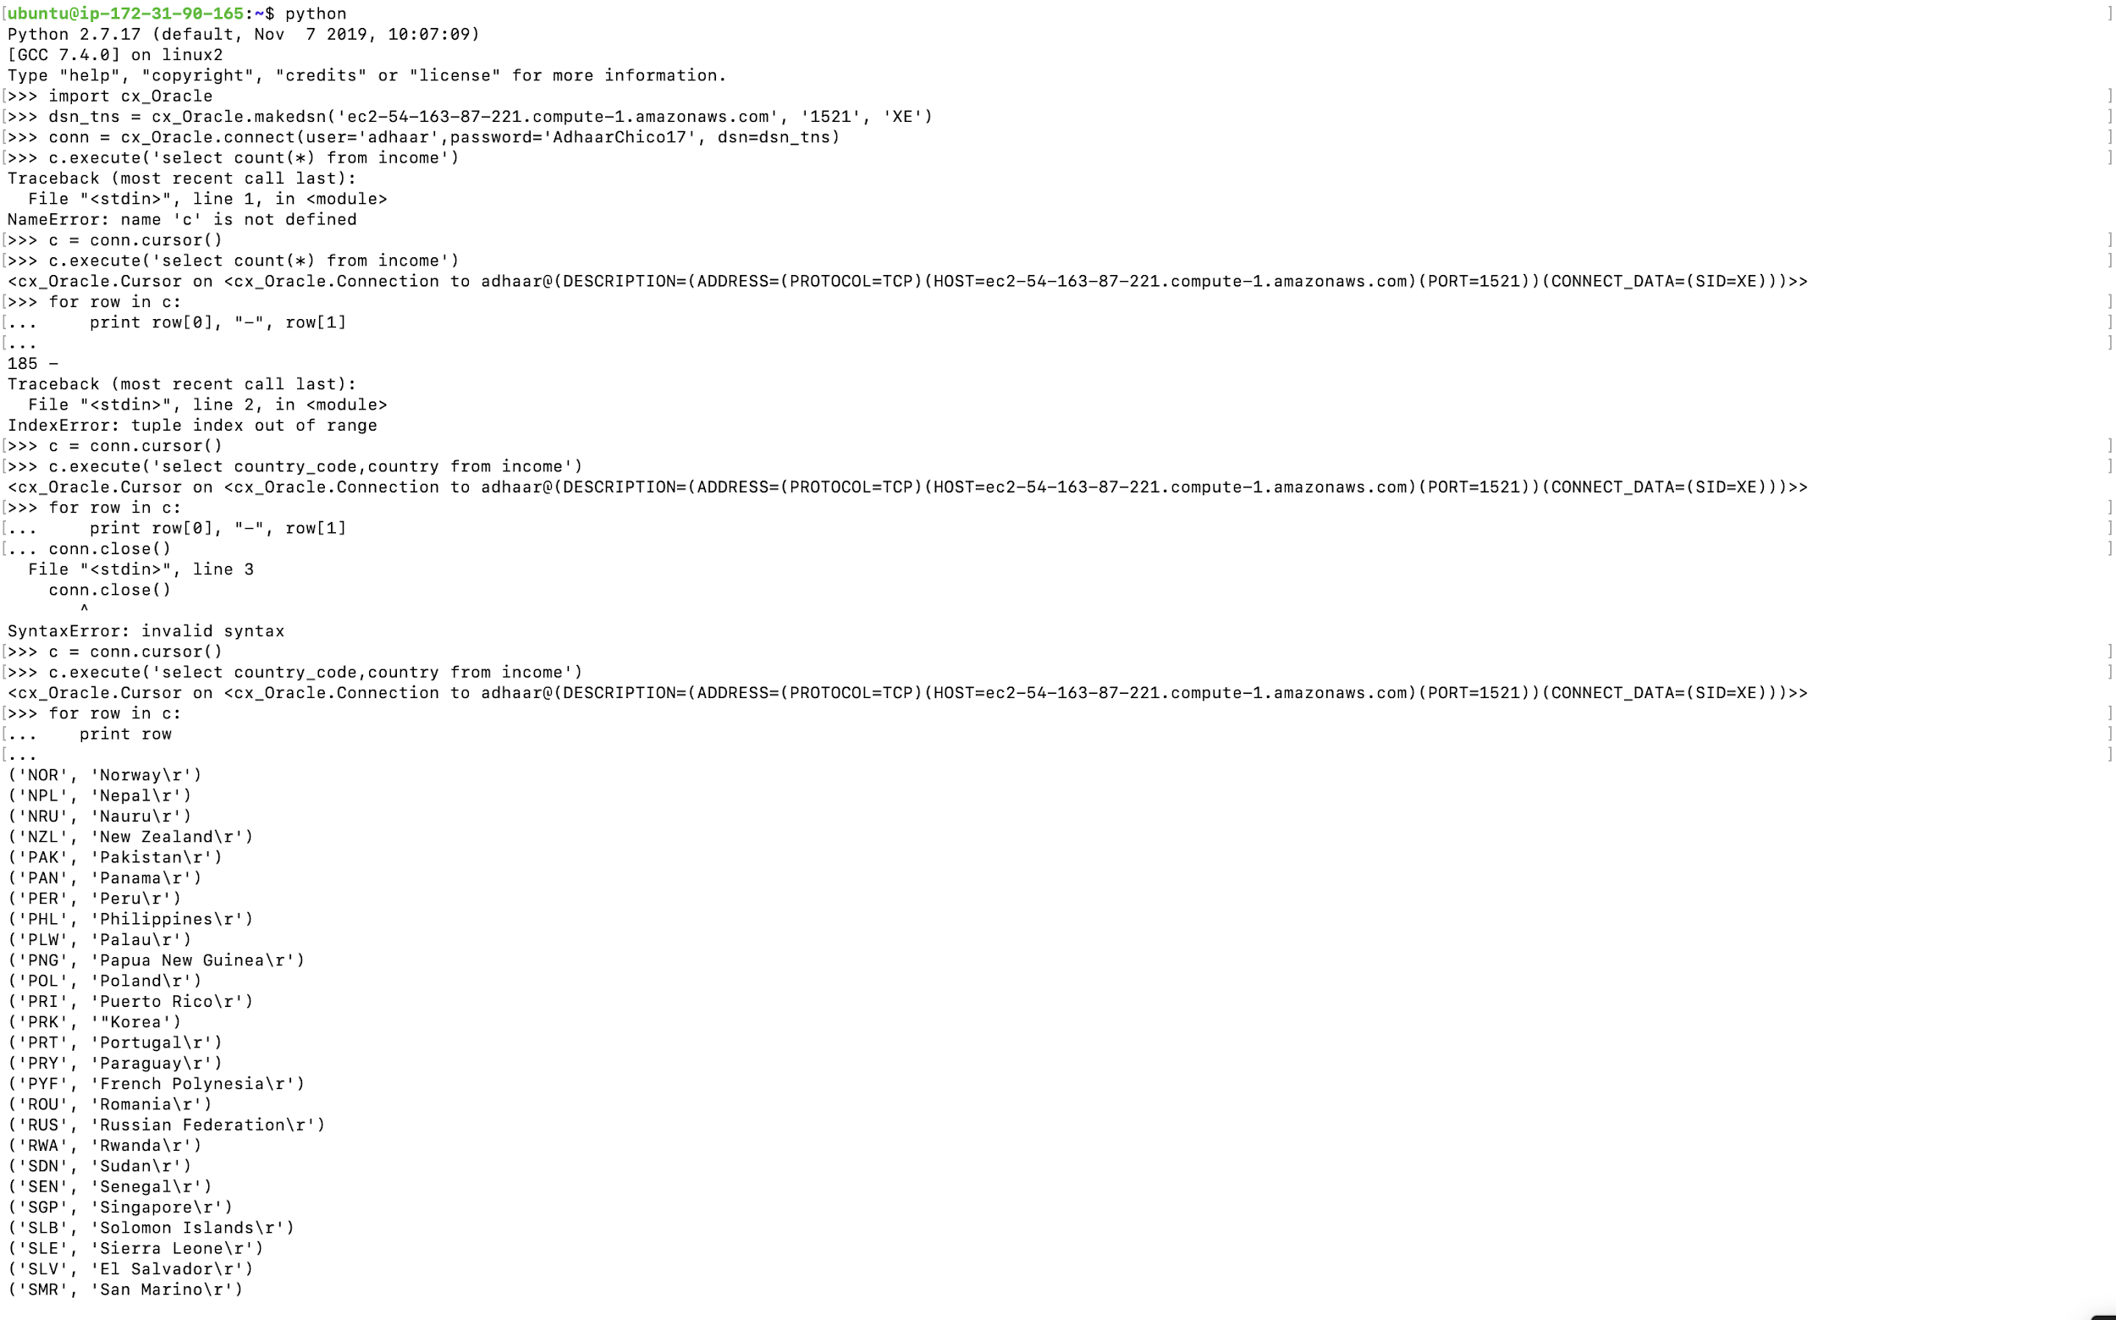

*GROUP MEMBERS*

* *Adhaar Jaiswal*
* *Viraj Sonavane*
* *Mansi Dogra*